Transport properties of a two-dimensional electron gas with spin-orbit coupling
Yik K. Lee^{1,*}, Jackson S. Smith¹, Jared H. Cole¹

¹Chemical and Quantum Physics, School of Science, RMIT University, Melbourne, Australia
*e-mail: yik.kheng.lee@student.rmit.edu.au

Given current power consumption trends, improvements in the energy efficiency of modern electronic devices are sorely needed [1]. Spintronics, where spin manipulation replaces charge manipulation, is a promising way to achieve this improvement. However, it is difficult to design such nanoscale devices because at these length scales their electrical transport properties are influenced by quantum effects.

One example of a nanoscale device is the two-dimensional electron gas (2DEG). In such a system, spin-orbit coupling (for example via the Rashba effect) leads to a coupling between the spin and momentum of conduction electrons. Furthermore, if an external magnetic field is applied, the Zeeman effect results in a coupling between the spin of the electrons and the external magnetic field. The interaction of these two effects leads to interesting topological phenomena such as the anomalous Hall effect and edge states [2,3].

The interplay of the Zeeman and Rashba effects allows for an important hurdle in spintronics to be overcome, namely, the spatial separation of electrons with different spins. By applying an out-of-plane magnetic field to a 2DEG, the electrons curve in a cyclotron motion and, due to the Rashba effect, electrons of different spins will have different Larmor radii (as shown in Fig. 1). This technique is called transverse magnetic focusing (TMF) and has been shown to be a viable way to separate electron spins [4,5,6]. We investigate the transport properties of a TMF system in a 2DEG using the non-equilibrium Green’s functions (NEGF) formalism, combined with a tight-binding model of the 2DEG. In doing so we analyze the effects of varying conditions such as spin-orbit coupling, magnetic field, device geometry, and disorder strength.
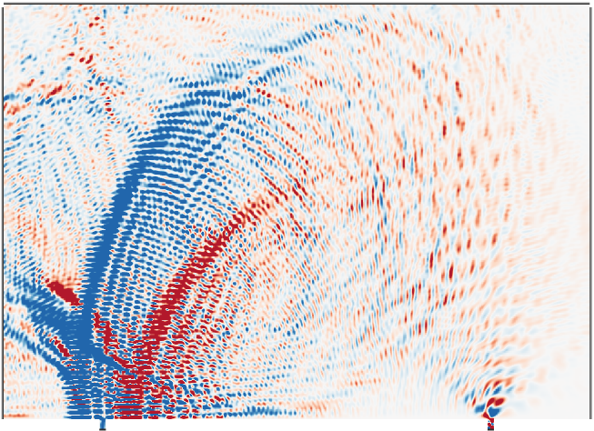
Fig. 1. Electron density for a 2DEG with an out-of-plane magnetic field (B_{z}) applied. Electrons are injected on the bottom right, and collected on the bottom left. The electrons are shown to separate into two paths, each corresponding to a different spin.

References
[1] A. Andrae, T. Edler, Challenges, 2015, 6(1), 117-157.
[2] C. Quay, et al., Nature, 2010, 6(5), 336-339.
[3] T. Nunner, G. Zaránd, F. von Oppen, Physical Review Letters, 2008, 100(23), 236602
[4] R. Potok, J. Folk, C. Marcus , V. Umansky, Physical Review Letters, 2002, 89(26), 266602.
[5] S. Bladwell, O. Sushkov, Physical Review B, 2015, 92(23), 235416.
[6] S.T. Lo et. al., Nature Communications, 2017, 8(), 15997.

