Raman biomedical diagnostics made possible
with custom-made gold nanostructured assemblies

Priyanka Dey^{A*}

^{A}School of Physics and Astronomy, University of Exeter, Exeter EX4 4QL, UK.

Introduction
Raman spectroscopy is a non-invasive radiation-free optical spectroscopy technique minimally affected by the presence of water in biological samples and thus has been growing in popularity as a biomedical diagnostic (imaging) modality. Due to the low number of Raman photons generated and the intense optical scattering by the tissue, it becomes quite challenging to collect Raman photons from deep within tissues. These can be overcome by utilizing the phenomenon of surface enhanced Raman scattering (SERS) in addition to modifying the spectrometer optics via spatially offset Raman spectroscopy (SORS) [Stone 2011, Dey 2013].
Methods
Employing controlled colloidally stable plasmonic gold nano-assemblies and utilizing SERS can aid in maximizing the Raman photons to be collected. We have strategically employed DNA and structural polymers to act as the molecular glue or linker to agglomerate gold nanoparticles into structural assemblies utilizing specific methodologies, providing a handle on SERS signal tunability. Controlling the nano-assembly absorbance, the SERS labels (tags) − type and methodology of incorporation, the optics and SORS set-up provides additional boost towards realizing the goal of Raman diagnostics.
Results and discussion
Carefully sculpting the morphology of these nano-assemblies (Fig. 1(i)) allows tuning their plasmonic coupling, resulting in increased absorbance in the near infrared (NIR) region of 650−1100 nm, popularly referred to as the tissue-transparency window [Dey 2013, Dey 2014]. We further report their NIR-SERS activity employing multiple SERS tags and tweaking its incorporation sequence in an attempt to maximize relative signal intensities. Finally, we would also elaborate on the critical factors required to obtain colloidally stable SERS-labelled gold nano-assemblies and their application in Raman diagnostics using SORS from deep within animal tissue, popularly referred to as SESORS (Fig. 1(ii)).
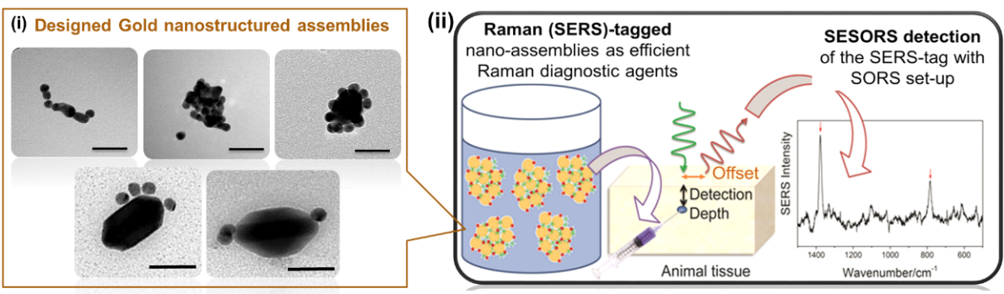
Fig. 1. (i) TEM images of different linker-mediated gold nano-assemblies (Scale bar = 50 nm). (ii) SERS-labelled (tagged) nano-assemblies for SESORS diagnostics.
Conclusions
Hence, each step is crucial including designing SERS-efficient nano-assemblies, following which labelling them adequately with SERS tags to maximize SERS signals and then employing them with modified Raman geometries like SORS to be able to detect the labelled nano-assemblies from deep within the tissue. All these done right will take us closer to making Raman diagnostics a clinical reality.
References
Stone, N. et. al., Chem. Sci. 2011, 2, 776-780. Dey, P. et al. J. Raman Spectrosc. 2013, 44 (12), 1659–1665. Dey, P. et al. Langmuir 2013, 29 (2), 525–533. Dey, P. et al. J. Mater. Chem. B 2014, 2, 2827-2837.

*e-mail: p.dey@exeter.ac.uk

