InAs-nanowire-based broadband ultrafast optical switch

Vladislav Khayrudinov^{A}, Junting Liu^{B}, He Yang^{A}, Yue Sun^{C}, Boris Matveev^{D}, Maxim Remennyi^{D}, Kejian Yang^{B}, Tuomas Haggren^{A}, Harri Lipsanen^{A}, Fengqiu Wang^{C}, Baitao Zhang^{B} and Jingliang He^{B}

^{A}Department of Electronics and Nanoengineering, Aalto University, Espoo, FI-00076, Finland; ^{B}State Key Laboratory of Crystal Materials, Institute of Crystal Materials, Shandong University, Shandong Jinan, 250100, China; ^{C}School of Electronic Science and Engineering, Nanjing University, 210023, China; ^{D}Ioffe Institute, St. Petersburg, 194021, Russia

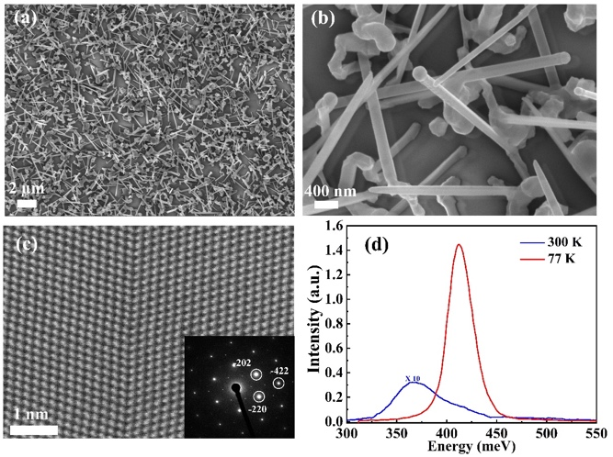
Indium arsenide (InAs) has attracted considerable interest in infrared optoelectronic and photonic devices. Here, we performed self-catalyzed growth of high quality InAs nanowires (NWs) on quartz by metalorganic vapor phase epitaxy (MOVPE) using a new isolated low-temperature growth regime (Fig. 1). We studied the ultrafast carrier dynamics and nonlinear optical responses of InAs NWs ranging from 1.0 to 2.8 µm and demonstrated the InAs-NW-based ultrafast broadband optical switch for passively Q-switching in all-solid-state laser systems (Fig. 2). Furthermore, we achieved ultrafast optical modulation for laser mode-locking at 1.0 μm, paving the way for NW applications in the field of ultrafast optics. These exotic optical properties indicate that InAs NWs have significant potential for various optoelectronic and photonic devices, especially in the mid-infrared wavelength range.
Fig. 1. Optical and electron microscopy characterization of InAs NWs
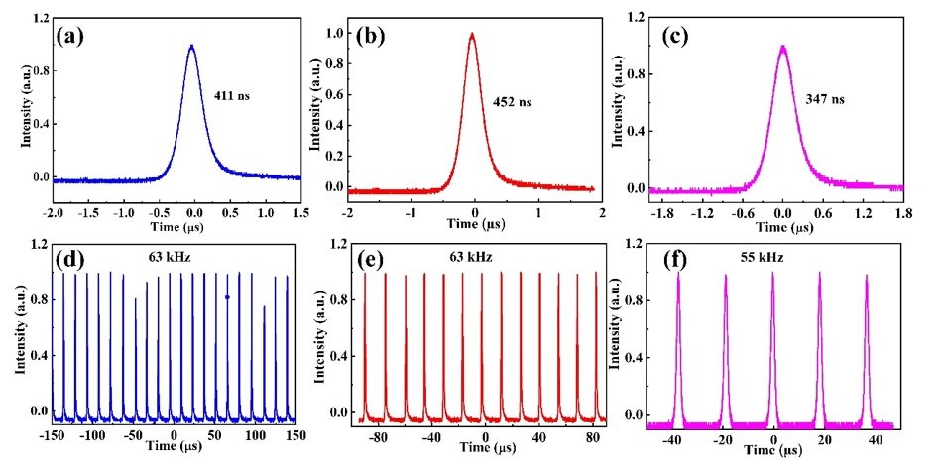
Fig. 2. Laser diagnostics at 1.0, 2.0 and 2.8 μm, separately (a)-(c). Corresponding passive Q-switched pulse trains (d)-(f).

References
- Liu, Junting, et al. "InAs-Nanowire-based Broadband Ultrafast Optical Switch." The Journal of Physical Chemistry Letters 2019 10 (15), 4429-4436

Corresponding Author:
vladislav.khayrudinov@aalto.fi

