Fluorescence properties of hydrogenated detonation nanodiamonds

Giannis Thalassinos^{A}, Alastair Stacey^{A}, Nikolai Dontschuk^{B}, Billy Murdoch^{C},
Hugues A. Girard^{D}, Lars Thomsen^{E}, Anton Tadich^{E}, Jean-Charles Arnault^{D}, Vadym Mochalin^{F}, Brant C. Gibson^{A}, Philipp Reineck^{A}

^{A}ARC Centre of Excellence for Nanoscale BioPhotonics (CNBP), RMIT University, Melbourne, Australia; ^{B}CQC2T, The University of Melbourne, Melbourne, Australia; ^{C}RMMF, RMIT University, Melbourne, Australia; ^{D}CEA, LIST, Diamond Sensors Laboratory, Paris, France; ^{E}Australian Synchrotron, ANSTO, Melbourne, Australia; ^{F}Missouri University of Science and Technology, Rolla, United States.

Detonation nanodiamonds (DND) have unique physical and chemical properties that have attracted great attention in the fundamental sciences. They also show great potential for many applications from drug delivery to composite materials.¹ Unlike high-pressure high-temperature nanodiamonds, their optical properties have to date received far less attention and are poorly understood. While fluorescence from known fluorescent defects in diamond such as the nitrogen-vacancy centre have been reported to exist in DNDs,^{2–4} fluorescence is also believed to originate from residual non-diamond carbon, which strongly depends on the particles’ surface chemistry.⁵ In the case of hydrogenated detonation nanodiamonds it remains unclear, whether their fluorescence originates mostly from non-diamond carbon-based surface defects or from color centers inside the DND particles.
Here we investigate the physiochemical and optical properties of hydrogenated DNDs, functionalised from the same oxidised starting material using two different techniques, namely via annealing in hydrogen and using plasma-assisted hydrogenation. The particles’ physiochemical properties were characterised using transmission electron microscopy (TEM), electron energy-loss spectroscopy (EELS), near-edge X-ray absorption spectroscopy (NEXAFS), X-ray photoelectron emission spectroscopy (XPS) and Fourier transform infrared spectroscopy (FTIR) as well as dynamic light scattering (DLS) to investigate the particles’ colloidal properties. We used in-solution spectroscopy and confocal fluorescence imaging and spectroscopy at room temperature and cryogenic temperatures to study the optical properties of both sample types in detail.
We find that both hydrogenation techniques increase the sp² content of the starting material of less than 5% to almost 20%. Both FTIR and NEXAFS results qualitatively show a successful hydrogenation of the particles. Both particle types show a strongly positive surface charge in aqueous suspension, while the sample annealed in hydrogen shows a very high zeta-potential of about +70 mV. Both samples show broad fluorescence between 550 nm and 800 nm under 450 nm light excitation (Figure 1). Dispersed on a silicon wafer substrate the fluorescence spectrum only blue-shifts by about 30 nm as the temperature decreases from room temperature to 10 K.
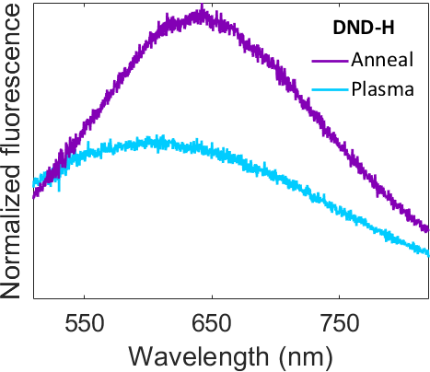
Fig 1. Normalized fluorescence spectra of both ‘anneal’ (narrow) and ‘plasma’ (wide) hydrogenated DND particles dispersed in water. Faded regions represent standard deviation.
References
¹ V.N. Mochalin, O. Shenderova, D. Ho, and Y. Gogotsi, Nat. Nanotechnol. 7, 11 (2012).
² C. Bradac, T. Gaebel, N. Naidoo, M.J. Sellars, J. Twamley, L.J. Brown, A.S. Barnard, T. Plakhotnik, A. V Zvyagin, and J.R. Rabeau, Nat. Nanotechnol. 5, 345 (2010).
³ P. Reineck, M. Capelli, D.W.M. Lau, J. Jeske, M.R. Field, T. Ohshima, A.D. Greentree, and B.C. Gibson, Nanoscale 9, 497 (2017).
⁴ S.L. Chang, A.S. Barnard, C. Dwyer, C. Boothroyd, R.K. Hocking, E. Osawa, and R.J. Nicholls, Nanoscale 1, 10548 (2016).
⁵ P. Reineck, D.W.M. Lau, E.R. Wilson, K. Fox, M.R. Field, C. Deeleepojananan, V.N. Mochalin, and B.C. Gibson, ACS Nano 11, 10924 (2017).

Author email: giannis.thalassions@rmit.edu.au

