Tracking macromolecular complexes in cells using pair correlation microscopy

Cameron W. Evans^{A}, Diwei Ho^{A}, Wenqian Wang^{B,C,D}, Jessica A. Kretzmann^{A}, Meenu Chopra^{A}, Marck Norret^{A}, Katharina Gaus^{C,E,F}, J. Justin Gooding^{B,C,D}, and K. Swaminathan Iyer^{A}

^{A}School of Molecular Sciences, The University of Western Australia, 35 Stirling Hwy, Crawley WA 6009; ^{B}School of Chemistry, UNSW Sydney; ^{C}Australian Centre for NanoMedicine, UNSW Sydney, High St, Kensington NSW 2052; ^{D}ARC Centre of Excellence in Convergent Bio-Nano Science and Technology, UNSW Sydney; ^{E}EMBL Australia Node in Single Molecule Science, UNSW Sydney; ^{F}ARC Centre of Excellence in Advanced Molecular Imaging, UNSW Sydney.

The realisation of gene therapies depends on a safe and efficient method to deliver nucleic acids to cells. Nonviral transfection is the process in which synthetic cationic polymers complex plasmid DNA to form polyplexes, which are internalised by cells, eventually reaching the nucleus where the DNA is transcribed. Polyplexes need to be sufficiently positively charged to encourage uptake, but successful transfection also relies on release of the genetic payload and transfer of DNA to the nucleus. There is a delicate balance between binding DNA strongly to promote formation of positively-charged nanoparticles, but dynamically enough to allow for release. We have designed a novel polymeric architecture consisting of highly hydrophilic and biocompatible poly(HEMA-ran-GMA) backbones bearing functionalised poly(amido amine) PAMAM dendrons (Figure 1).¹ This system confers a high level of control in preparing transfection agents with different charge, charge density, and molecular flexibility. A variety of different charge densities and functional group modifications have been investigated for their ability to successfully transfect MCF-7 human breast adenocarcinoma cells. Different polymer variants result in different levels of transfection, but it is not always clear why a particular polymer promotes or limits this process. Here, we use confocal microscopy together with pair correlation analysis to investigate the motion of polyplexes, DNA, and transfection agents in live cells.² Our recent work analysing transfection by tracking Cy3-tagged pDNA and Cy5-labelled polymers and their motion within MCF-7 cells will be presented. This information is used to reveal which functionalised polymers are most strongly bound to DNA in the cell and how quickly the various modified polymers and polyplexes traverse cellular compartments and membranes. Such information will be related to experimentally observed transfection efficiencies. As the field advances towards delivery of recombinant proteins rather than plasmids, we will conclude by showing protein delivery data that makes use of a similar polymeric design and similar functional group variants.

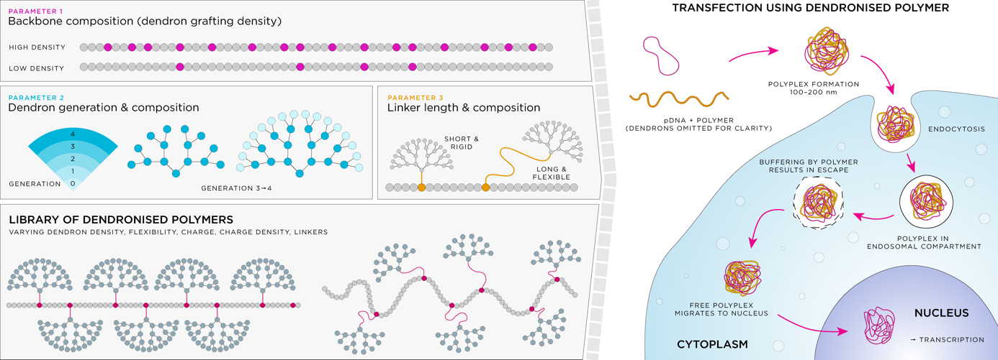
Figure 1. Nonviral transfections are highly dependent on molecular architecture, charge density, and flexibility. The preparation of a library of polymers (left panel) and their testing in subsequent transfection (right panel) results in various transfection efficiencies that will be discussed.

References
- J.A. Kretzmann et al., Chem. Sci. 8, 2923 (2017); Chem. Sci. doi:10.1039/c9sc01432b (2019).
- E. Hinde et al., Nat. Nanotechnol. 12, 81 (2016).

