Super-transport of Excitons in Atomically Thin Organic Semiconductors at the 2D Quantum Limit

Ankur Sharma, and Yuerui Lu

Research School of Engineering, College of Engineering and Computer Science, The Australian National University, Canberra, ACT, 2601, Australia

Abstract:
Long-range and ultrafast transport of coherent excitons is important for development of high-speed excitonic circuits and quantum computing applications. However, most of these coherent excitons have only been observed in some low-dimensional semiconductors when coupled with cavities, as there are large inhomogeneous broadening and dephasing effects on the exciton transport in their native states of the materials. Here, by confining coherent excitons at the 2D quantum limit, we firstly observed molecular aggregation enabled ‘super-transport’ of excitons in atomically thin two-dimensional (2D) organic semiconductors between coherent states, with a measured ultra-high effective exciton diffusion coefficient of ~346.9 cm²/sec at room temperature. This value is one to several orders of magnitude higher than the reported values from other organic molecular aggregates and low-dimensional inorganic materials. Without coupling to any optical cavities, the monolayer pentacene sample, an ultraclean 2D quantum system (~1.2 nm thick) with high crystallinity (J-type aggregation) and minimal interfacial states, showed superradiant emissions from the Frenkel excitons, which was experimentally confirmed by the temperature-dependent photoluminescence (PL) emission, highly enhanced radiative decay rate, significantly narrowed PL peak width and strongly directional in-plane emission. The coherence in monolayer pentacene samples was observed to be delocalized over ~150 molecules, which is significantly larger than the values (a few molecules) observed from other organic thin films. In addition, the super-transport of excitons in monolayer pentacene samples showed highly anisotropic behaviour. Our results pave the way for the development of future high-speed excitonic circuits, quantum computing devices, fast OLEDs, and other opto-electronic devices.
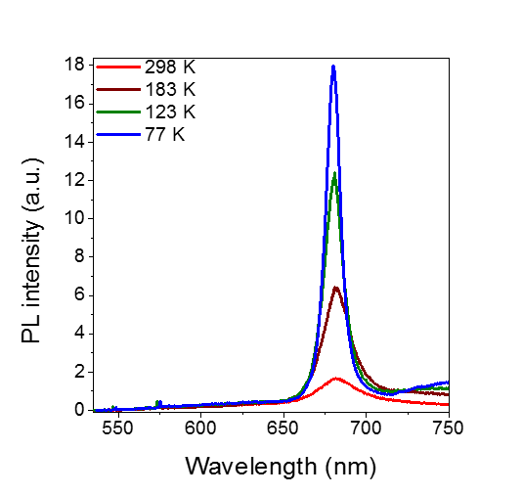

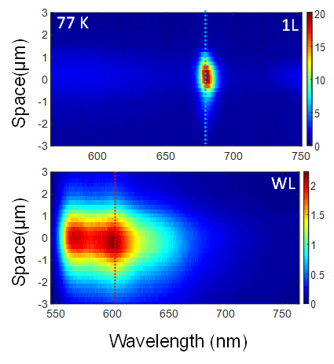

Fig 1: (a) Measured PL spectra at various temperatures from 1L pentacene. The sharp peak at ~680 nm (designated as frenkel excitonic emission) rises sharply as temperature decreases, demonstrating superradiance. (b)Measured contour plots of PL intensity as a function of emission wavelength and space of exciton diffusion from 1L and WL pentacene samples at 77 K, showing super-transport of frenkel excitons. The middle of laser excitation spot is at x = 0.

