Local geometrical error corrections for a metrological scanning probe microscope

Bakir Babic, Victoria A. Coleman and Jan Herrmann
Nanometrology Section, National Measurement Institute Australia, Lindfield, NSW 2070, Australia.

The measurement accuracy of an instrument is depended upon the accuracy of the artefact used to calibrate it. The features on a calibration artefact like step height and pitch length, must be measured traceably, ideally with a highest accuracy instrument, recognized as a primary standard. In the case of nanometrology, a primary standard is commonly realised as a metrological scanning probe microscope (mSPM). The mSPM developed at the National Measurement Institute Australia achieves traceability by heterodyne interferometric measurement of the displacement of a sample translation stage using a frequency stabilised laser linked to the realisation of the SI metre [1]. The three-dimensional (3D) motion of a nano positioning stage is measured by five interferometers, one for each of the three translational axes and two for monitoring stage rotations.
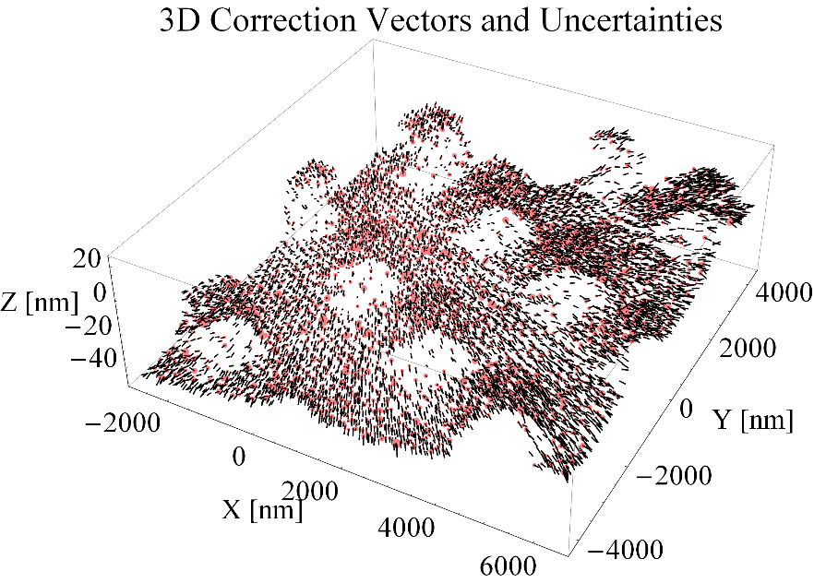
The design of the mSPM follows metrological principles to minimise measurement uncertainties caused by alignment errors, thermal variations, mechanical distortions, and environmental vibrations. The Abbé errors, cosine errors and other alignment errors such as non-flatness of the stage with respect to the movable mirror form a set of geometrical errors. These errors are minimised through the system design and appropriate alignment procedures. However, if additional channels of information are available, these errors can be further reduced [3] through understanding how the new measured parameters contribute to the uncertainty budget. Measurements of parasitic stage rotations by angular interferometers can be used to determine the geometrical errors. Combining this with an appropriate model which relates the stage motion and the interferometric measurement configuration through known geometrical parameters such as the dimensions of the movable mirror, it is possible to determine and correct for local geometrical errors. This local geometrical error correction method ensures that the error between each subsequent measurement steps is evaluated. This allows each measurement point to be corrected and complemented by calculation of the corresponding local uncertainty arising from the geometrical errors. An application of the local error correction method for a typical mSPM scan of a height calibration artefact is illustrated in the figure, where every 126th point from the acquired data set is shown. In this image, the local error corrections are visualised with vectors (in black) and the corresponding uncertainties with spheres (in red). The 3D features of the measured structure are clearly recognisable. 90% of the correction vector components range between ±2 nm, whereas the maximum local uncertainty is ~ 0.5 nm. The uncertainty of the geometrical error is dominated by the uncertainty of the Abbé error offset ± 100 µm while the angular errors are determined by the scan step size and are limited by the alignment uncertainties and resolution of the angular interferometers.

References
- Babic, B. Freund, C. Coleman, V. A. & Herrmann, J. (2018). A metrological Scanning Probe Microscope for accurate length measurements at the nanoscale. Australian Physics 55 (1), 214307.
- Babic, B. Freund, C. Coleman, V. A. & Herrmann, J. (2016). A method for estimating and reducing Abbé off-sets in the metrological scanning probe microscope at the National Measurement Institute Australia. Nanoscale conference proceedings.
- Klapetek, P. N󠄍ečas, D. Campbellová, A. Yacoot, A. & Koenders L. (2011). Methods for determining and processing 3D errors and uncertainties for AFM data analysis. Meas. Sci. Technol. 22, 025501.

