Synthesis of a biodegradable-pH sensitive self-assembled polymeric theranostics for hepatic fibrosis

Arunpandian Balaji^{A,B,C}, Craig A. Bell^{A,B,C}, Zachary H. Houston^{A,B,C}, Kristofer J. Thurecht^{A,B,C}
^{A}Australian Institute of Bioengineering and Nanotechnology, University of Queensland, Brisbane 4072, Australia; ^{B}Centre for Advanced Imaging, University of Queensland, Brisbane 4072, Australia; ^{C}ARC Centre of Excellence in Convergent Bio-Nano Science and Technology, University of Queensland, Brisbane 4072, Australia
Introduction: Hepatic fibrosis (HF) is a common pathological feature of different liver diseases. Activated hepatic stellate cells, a prime mediator of HF, is the target for most of the anti-fibrotic agents. However, the lack of specificity and severe toxicity associated with systemically administered anti-fibrotic drugs significantly limits its clinical application, and there are currently no FDA approved drugs available for HF (Bhatia et al. 2014, Forbes et al. 2016)
Methods: Recently, nanoparticle-based drug delivery systems have shown great potential to deliver drugs to the fibrotic liver. However, more in-depth research is required to understand the effect of targeting ligands used and the fibrosis stage on the intrahepatic distribution of nanoparticles (Pellicoro et al. 2014). For this purpose, a biodegradable polymer system was synthesized using reversible deactivation radical polymerisation (RDRP) of 2-methylene-1,3-dioxepane (MDO) and vinyl levulinate using a PEG-based xanthate macro-chain transfer agent (CTA)
Results: Block copolymers (PEG-b-poly(VL-co-MDO)) with an average molecular weight (M_{n}) of 10 kDa was successfully synthesized. These polymer chains exhibited complete degradation in PBS (pH - 7.4, 37 ˚C) due to the hydrolysis of randomly arranged ester bonds in the polymer backbone. Upon slow addition of water, the polymers self-assembled to form micelles, which were then successfully cross-linked via pH-sensitive hydrazone bonds to obtain nanoparticles with a number-average hydrodynamic diameter (D_{H}) of 30 nm (Fig 1). Furthermore, the protected functional group on the nanoparticle surface was utilized to conjugate targeting ligands and a positron emission tomography (PET) chelator
Conclusion: A novel biodegradable polymeric-nanoparticle system with optimal physicochemical properties and biodistribution profile was successfully developed. In future work, the efficacy of these nanoparticles will be tested in animal models at various stages of HF.
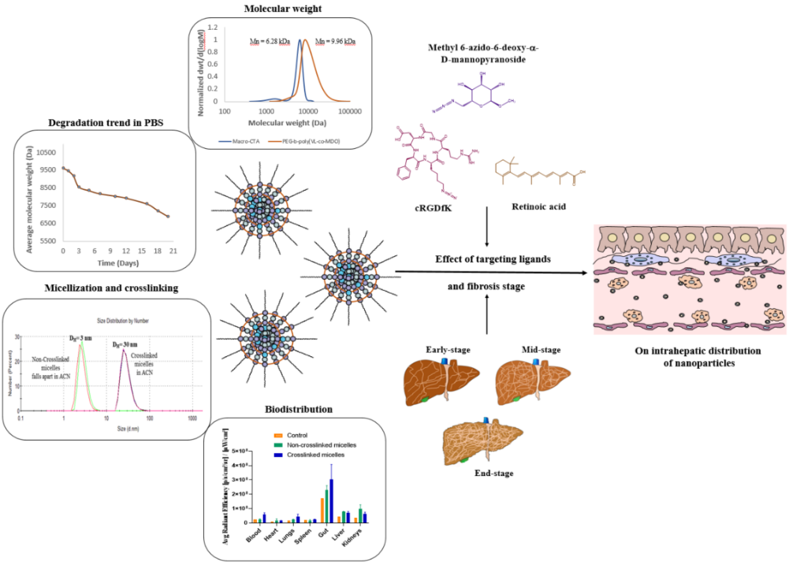

Figure 1. Development of a novel drug delivery system for hepatic fibrosis

References
Bhatia, SN., Underhill, GH., Zaret, KS., Fox, IJ (2014). Cell and tissue engineering for liver disease. Sci Transl Med., 6, 1-21.
Forbes, SJ & Newsome, PN. (2016). Liver regeneration - mechanisms and models to clinical application. Nat Rev Gastroenterol Hepatol., 13, 473-85.
Pellicoro, A., Ramachandran, P., Iredale, JP., Fallowfield, JA., (2014). Liver fibrosis and repair: immune regulation of wound healing in a solid organ. Nat. Rev. Immunol., 14, 181-194.

