Vortex Fluidic Mediated Synthesis of Macroporous Bovine Serum Albumin-Based Microspheres
Xuan Luo^{A,B}, Ahmed Hussein Mohammed Al-Antaki^{A}, David P. Harvey^{A}, Yinlan Ruan^{C}, Shan He^{D}, Wei Zhang^{B}, and Colin L. Raston^{A}
^{A}Flinders Institute for NanoScale Science and Technology (CNST), College of Science and Engineering; ^{B}Flinders Centre for Marine Bioproducts Development, College of Medicine and Public Health, Flinders University, Adelaide, Australia; ^{C}ARC Centre of Excellence for Nanoscale BioPhotonics, Institute of Photonics and Advanced Sensing, Adelaide University, Adelaide, Australia; ^{D}Department of Food Science and Engineering, School of Chemistry Chemical Engineering, Guangzhou University, China.

Macroporous bovine serum albumin (BSA) nanoparticles with controllable diameter were readily fabricated in a rapidly rotating angled glass tube in a vortex fluidic device (VFD). Systematically varying the rotational speed and the ratio of BSA, ethanol, and glutaraldehyde led to conditions for generating ca. 600 nm diameter macroporous particles that have intrinsic fluorescence emission at 520 nm when excited at 490 nm. The presence of the macropores increased the absorption efficiency of rhodamine B with potential applications for drug delivery purpose, compared with BSA nanoparticles having surfaces devoid of pores. Further control over the size of BSA nanoparticles occurred in the presence of C-phycocyanin protein during the VFD processing, along with control of their shape, from spheres to pockets, as established in exploring the parameter space of the microfluidic device.

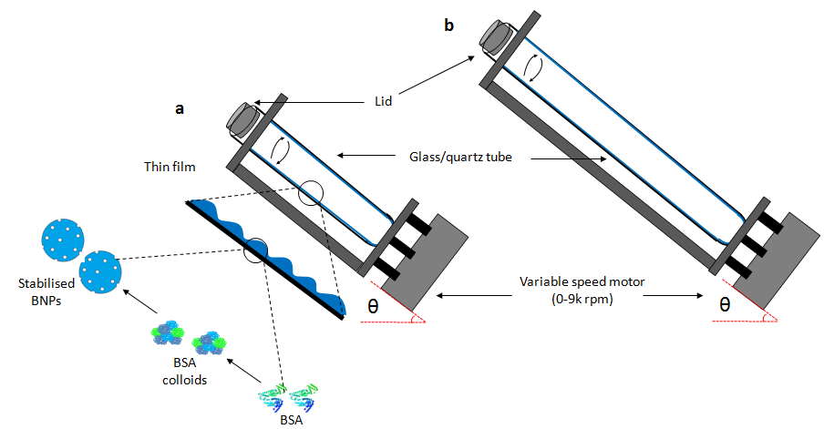
References
Luo, X., Al-Antaki, A. H. M., Harvey, D., Ruan, Y., He, S., Zhang, W. & Raston, C. (2018). Vortex Fluidic Mediated Synthesis of Macroporous Bovine Serum Albumin-Based Microspheres. ACS Appl. Mater. Inter., 10, 27224-27232.

