Reducing oxidative stress by enzyme-loaded nanoparticle dispersions

Istvan Szilagyi
MTA-SZTE Biocolloids Research Group, University of Szeged, Hungary
email: szistvan@chem.u-szeged.hu

Introduction. Oxidative stress caused by reactive oxygen species (ROS) induces several diseases by damaging cell constituents. Antioxidant enzymes including superoxide dismutase (SOD) and horseradish peroxidase (HRP) are members of the primary defence system developed against ROS. However, their supplementation to living organisms is limited due to their high sensitivity to the environmental conditions such as pH, ionic strength and temperature. To overcome this challenge, enzyme immobilization on biocompatible nanomaterials is a promising way to obtain composites of antioxidant activity. The solid supports are required to provide functional stability for the enzymes. These delivery systems must also possess high colloidal stability to avoid aggregation once dispersed in bio-fluids such as blood.

Aims. We aimed at the development of an antioxidant hybrid materials consisting of SOD and HRP enzymes as well as polyelectrolyte-functionalized layered double hydroxide (LDH) nanoparticles.

Methods. Structural features were studied with scanning electron microscopy, X-ray diffraction and Infrared spectroscopy in solid state. Charging and aggregation processes were explored with dynamic and electrophoretic light scattering techniques in dispersions. The antioxidant activities were assessed in biochemical assays and in cell viability tests.

Results and Discussion. Two-dimensional LDH nanoparticles of narrow size distribution were synthesized by a hydrothermal method. Surface functionalization was carried out with heparin (HEP) polyelectrolyte via electrostatic interaction and hydrogen bonding. Due to the precise optimization of the experimental conditions during preparation, stable LDH-HEP dispersions were obtained, which possessed extremely high resistance against salt induced aggregation. Immobilization of SOD and HRP was carried out by physical adsorption. Both LDH-SOD-HEP and LDH-HEP-HRP composites showed high activity in decomposition of superoxide radicals and hydrogen peroxide, respectively. To mimic the cellular environment, the enzymes were co-immobilized using the sequential adsorption method in the LDH-HEP-HRP-PLL-SOD-HEP order, where PLL refers to polylysine (Figure 1).

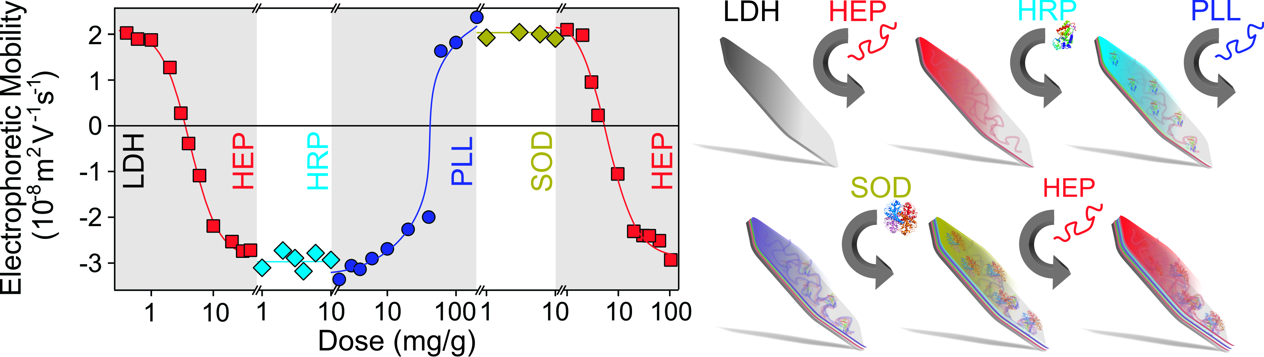
Figure 1. Charging behavior (represented by electrophoretic mobility values measured at different polyelectrolyte or enzymes doses) during the preparation process of the LDH-HEP-HRP-PLL-SOD-HEP.

The experimental conditions were refined in the synthesis that the multicomponent material formed highly stable colloid. As confirmed in biochemical assays, the developed enzymatic cascade system has proven as an efficient antioxidant for decomposition of superoxide radicals and hydrogen peroxide. Moreover, it was also active in protection of living cells against oxidative stress.

Conclusion. The obtained bionanocomposite, consisted of LDH particles, antioxidant enzymes and polyelectrolytes, of high structural, colloidal and functional stability is a promising antioxidant candidate in applications, wherever the goal is to reduce oxidative stress in heterogeneous systems.

