In situ etching and functionalization of two-dimensional materials

Charlene J. Lobo
School of Mathematical and Physical Sciences, University of Technology Sydney, Ultimo, Australia.

Focused electron beam induced deposition and etching are direct-write nanofabrication techniques in which an electron beam is used to achieve nanostructure functionalization, etching or deposition. Either alone or in combination with in situ plasmas, these techniques can also be used to accelerate reactions that occur in ambient environment, while also enabling simultaneous high-resolution imaging. Here, I will discuss recent experimental work on in situ etching and functionalization the two-dimensional materials hexagonal boron nitride and few-layer black phosphorus. High resolution electron beam etching of hexagonal boron nitride is demonstrated under 8 Pa water vapour in an environmental scanning electron microscope (ESEM). The hBN undergoes denitrogenation under electron beam induced etching in H₂O, forming volatile NO and NO₂ and leaving behind boron nanoparticles. Under continued irradiation, the dissociated H₂O molecules react with NO and NO₂ species to produce nitric acid, which etches the deposited boron nanoparticles, resulting in highly localized, clean etching of the hBN. Raman analysis demonstrates that the surrounding hBN material is not damaged by the etch process, enabling damage-free electron beam fabrication of well-defined hBN nanoribbons, holes and other geometries¹. We also study the stability of another two-dimensional material, few-layer black phosphorus (FLBP) in H₂O, O₂, NF₃ and NH₃ environments using ESEM and in situ electrical conductance measurements. The electron beam is used both for ESEM imaging, and also to generate reactive species such as *O, *OH, *F and *H that can drive spatially-localized chemical reactions at the sample surface. Electron-beam irradiation in H₂O vapour is known to generate reactive oxygen species (ROS) that are responsible for the degradation of FLBP in ambient environment, but FLBP stability has not been assessed during prolonged exposure to other gaseous environments. Using our novel experimental approach, we demonstrate a number of promising methods of protecting FLBP and other moisture-sensitive two-dimensional materials from degradation by ROS. Our results demonstrate the utility of in situ electron and ion beam techniques for high-resolution, real-time imaging of chemical reactions occurring in synthetic two-dimensional materials such as few-layer black phosphorus.

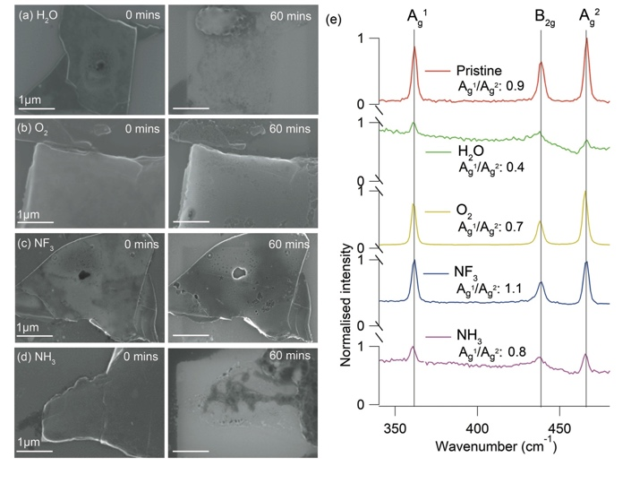
Figure 1. a-d) ESEM images of FLBP before (left) and after (right) 60 minute electron beam irradiation in H₂O, O₂, NF₃, and NH₃ environments at RT and 8 Pa chamber pressure. Irradiation and imaging were conducted using an accelerating voltage of 15kV and electron beam flux of 2.3x10¹⁹ electrons cm⁻²min⁻¹. The scale bar is 1 µm. e) Normalised Raman spectra taken along the b axis of pristine FLBP (top), and from each of the flakes shown in (a)-(d).

