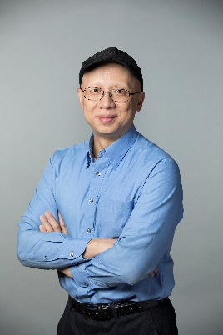
Title: Microfluidics for tools in nanomedicine
Xingyu Jiang
Southern University of Science and Technology, Shenzhen, China

National Center for NanoScience and Technology,
University of Chinese Academy of Sciences, China

Biography: Xingyu Jiang is a Chair Professor at the Southern University of Science and Technology, Shenzhen, China. He obtained his BS at the University of Chicago (1999) and PhD at Harvard University (with Prof. George Whitesides, 2004). In 2005, he joined the National Center for NanoScience and Technology and the University of the Chinese Academy of Sciences. He moved to the Southern University of Science and Technology in 2018. His research interests include microfluidics and nanomedicine. He was awarded the “Hundred Talents Plan” of the Chinese Academy of Sciences, the National Science Foundation of China’s Distinguished Young Scholars Award, the Scopus Young Researcher Gold Award, the Human Frontier Science Program Young Investigator Award. He is a Fellow of the Royal Society of Chemistry, an associate editor of Nanoscale (Royal Society of Chemistry, UK).

Abstract: Microfluidics represent an appealing platform for synthesis, screening and discovery of nanoscale therapeutics. We demonstrate that microfluidics can dramatically improve the efficiency of many clinically relevant assays and screens. Driven by miniaturization and surface chemistry, microscale-chips allow the assays of potential drug carriers and novel drugs, with improved throughput, sensitivity and stability. Combined with nanoparticles and nano-materials, microfluidics show great promise in developing novel therapeutics. For example, these platforms are also extraordinarily useful for screening of therapeutics, e.g., nanocarriers for introducing siRNA, CRISPR/Cas, and so forth.

Selected references:
Cao HY, Wang YY, Gao Y, Deng XL, Cong YL, Liu Y, Jiang XY, Angew Chem Int Ed, (2019), 1626-1631.
Yang MZ, Liu Y, Jiang XY, Chem Soc Rev, (2019), 850-884.
Xianyu YL, Wu J, Chen Y, Zheng W, Xie M, Jiang XY, Angew Chem Int Ed, 130, 7625-7639. (2018).
M. Yang, Y. Chen, J. Yang, W. Zheng, X. Jiang,. Science Advances, DOI: 10.1126/sciadv.aao4862 (2017).
Lei YF, Tang LX, Xie YZY, Xianyu YL, Zhang LM, Wang P, Hamada Y, Jiang K, Zheng WF, Jiang XY, Nature Communications, DOI: 10.1038/ncomms15130. (2017)
Zhang L, Feng Q, Wang JL, Sun JS, Shi XH, Jiang XY. Angew Chem Int Ed, 54, 3952-3956. (2015)
Sun JS, Zhang L, Wang JD, Feng Q, Liu DB, Yin QF, Xu DY, Wei YJ, Ding BQ, Shi XH, Jiang XY, Adv Mater, 2015, 27, 1402-1407. (2015).
Sun J, Xianyu YL, Jiang XY, Chem Soc Rev, 43, 6239-6253. (2014).

