Selective Control of Surface Spin Current in Topological Materials

Yuefeng Yin^{A,B,*}, Michael S. Fuhrer^{A,B} and Nikhil V. Medhekar ^{A}
^{A} Department of Materials Science and Engineering, Monash University, Australia
^{B} School of Physics and Astronomy, Monash University, Australia

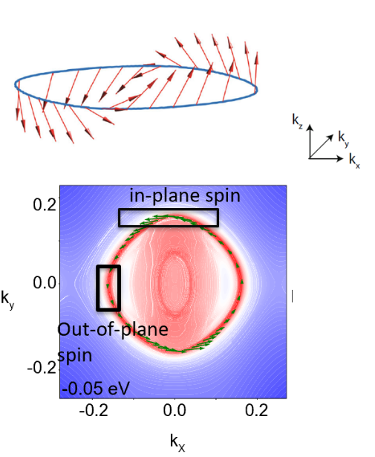
Introduction.

Manipulating and detecting spin polarization is a vital challenge for designing novel spin-based nanoelectronic devices [Li and Yang 2016]. Recent years topological materials have shown promising potentials in spintronics applications due to their unique spin textures [Tokura et al. 2019]. Here we report the existence of highly anisotropic surface spin textures in the surfaces of topological material OsX₂ (X = Se, Te). The spin polarization of these materials can be selectively tuned from in-plane to out-plane.[Yin et al. 2019]

Methods.

We use first principles calculations as implemented in VASP [Kresse and Furthmuller 1996] to calculate the electronic structure. The topological properties and surface electronic structure are examined using open source code WannierTools based on Wannier tight-binding models [Wu et al. 2018, Mostofi et al. 2014].
Fig. 1. The surface spin textures of OsX₂ (X = Se, Te)

Results and Discussions

Bulk OsX₂ is a non-magnetic semimetallic pyrite-type crystal with topologically nontrivial band structure. The strong spin orbit coupling (SOC) effects of Os atoms leads to band inversion between Os d orbitals and Se p orbitals near the Fermi level. The (001) surface of OsX₂ features surface bands with both in-plane and out-of-plane spin components. The surface spin direction and magnitude can be selectively filtered in specific energy ranges (see Fig. 1). Such surface spin currents are protected by local crystalline symmetries and are robust against non-magnetic crystalline impurities.

Conclusion

The discovery of unconventional surface spin textures in OsX₂ (X=Se,Te) broadens our understanding of spin polarization in non-magnetic materials and tuning spin polarizations in topological materials. We expect the results of this study can also provide new insights for generating spin current in spin logic devices, which requires different magnitude and direction of spin components to transport information.

References
Li, X. and Yang, J. (2016) First-principles design of spintronics materials. Natl. Sci. Rev. 3, 365-381.
Kresse, G. and Furthmuller, J. (1996). Efficient iterative schemes for ab initio total-energy calculations
using a plane-wave basis set. Phys. Rev. B, 54, 11169-11186.
Mostofi et al. (2014). A tool for obtaining maximally localised Wannier functions. Comput. Phys. Commun. 185, 2309-2310.
Tokura et al. (2019) Magnetic topological insulators, Nat. Rev. Phys., 1, 126-143
Wu et al. (2018) WannierTools: An open-source software package for novel topological materials. Comput. Phys. Commun. 224, 405-416.
Yin et al. (2019) Selective control of surface spin current in topological pyrite-type OsX2 (X = Se, Te) crystals. npj Quantum Mater. doi:10.1038/s41535-019-0186-8.
*Corresponding author. email: yuefeng.yin@monash.edu

