Porous upconversion nanostructures as multimodal contrast agent
for biomedical imaging

Ziqing Du^{A}, Abhishek Gupta^{B}, Deming Liu^{A}, Zhuoqing Yang^{C}, Xiaoxue Xu^{A*}

^{A}Institute for Biomedical Materials and Devices, Faculty of Science, University of Technology Sydney, NSW, 2007, Australia
^{B}Nanoscale Organisation and Dynamics Group, School of science and health, University of Western Sydney, NSW, 2000, Australia
^{C}National Key Laboratory of Science and Technology on Micro/Nano Fabrication, Shanghai Jiao Tong University, Shanghai, 200240, P. R. China

Introduction and aim
Due to the metastable energy levels and unquenched orbital angular momentum (Auzel 2004), unique optical and magnetic properties of lanthanide ions doped upconversion nanoparticle (UCNPs) have attracted broad attention in bioimaging area (Generalova et al 2017). The multimodal ability of UCNPs enables the applications as a contrast agent in fluorescent bioimaging (FBI), magnetic resonance imaging (MRI), and computed tomography (CT). We fabricated the novel core-porous shell UCNPs aiming at improvements in FBI intensity and MRI contrast.

Results and Discussion
The TEM images (Fig. 1a-b) show the highly uniform core-dense shell and core-porous shell UCNPs in 50 nm with the 40 nm core. The porous structure can be observed on the shell of UCNPs which was formed via the dissolution of the relatively unstable NaYF₄ and the growth of more stable KGdF₄ from the NaYF₄:30%Gd shell. The PL spectra of the core, core-dense shell, and core-porous shell UCNPs in Fig 1(c) shows that the emission intensity increased fifteen times with dense shell and ten times with porous shell coating. The brightness was greatly enhanced. The dense shell coating dramatically minimized the surface quenching to the luminescent emission and the porous shell functionalized as the protecting shell with a slight decreasing in emission. The ionic relaxivity (unit [Gd³⁺]) values of the core-shell and core-porous shell UCNPs in the magnetic field of 11.7 T and 1 T demonstrated the porous shell exposed more Gd to contact with protons and generated significantly higher r2 values, thus the MRI signals were also improved from the porous shell structure.
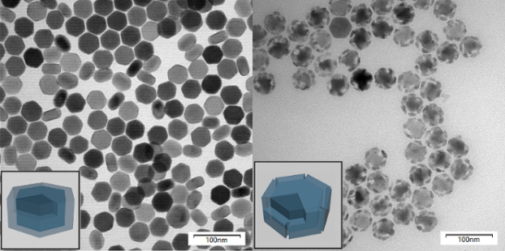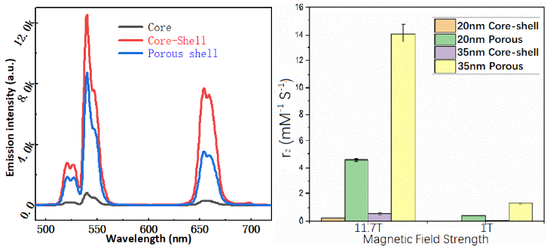
Fig. 1: TEM images of (a) core-shell and (b) core-porous shell UCNPs. The (c) PL and (d) r2 relaxivity at 11.7 T and 1 T magnetic field of core-shell and core-porous shell UCNPs.

Conclusion
The porous shell was successfully coated onto UCNPs core, and the core-porous shell UNCPs is a novel structure. The significant enhancement on both optical and magnetic performance proved the effectiveness and applicability of core-dense shell and core-porous shell UCNPs as a multimodal contrast agent. The core-porous shell UCNPs is an advantaged multimodal bioimaging contrast agent with benefited performance. This work demonstrated a new strategy for optimizing the physical properties of UCNPs for biomedical imaging application.

References
1. Auzel, F., Chemical reviews (2004) 104 (1), 139
2. Generalova, A. N., et al., Advances in colloid and interface science (2017) 245, 1
3. Wang, F., et al., Nature protocols (2014) 9 (7), 1634

