Harnessing Solar Energy through Nano-Catalysts for Power to X

Rose Amal

School of Chemical Engineering, UNSW, Sydney, NSW 2052, Australia.

Email address of presenting author: r.amal@unsw.edu.au

Catalysis is the heart of chemistry – most chemical reactions need catalysts – so we want to make these reactions efficient and the process as sustainable as possible. Turning to solar as an energy source to activate nano-catalysts is an obvious place to focus our investigations because it reduces our reliance on unsustainable fossil fuels. There are a number of means in utilising the sun’s energy to drive energetically demanding catalytic processes. We can use (i) electricity from photovoltaic transformation of sunlight to drive electro-catalytic reactions, (ii) heat of the sun to activate thermal catalyst, and (iii) light of the sun to excite electrons from valence band of a semiconductor to its conduction band.
Here, we present our ongoing research in harnessing the full solar energy spectrum (from ultraviolet to infra-red) using nano-catalysts to induce or/and enhance catalytic CO₂ reduction. Using solar energy to catalytically reduce CO₂ has the potential to convert the waste CO₂ into fuel and feedstocks, allowing the dual opportunity to store the intermittent renewable energy as well as closing the anthropogenic carbon cycle.
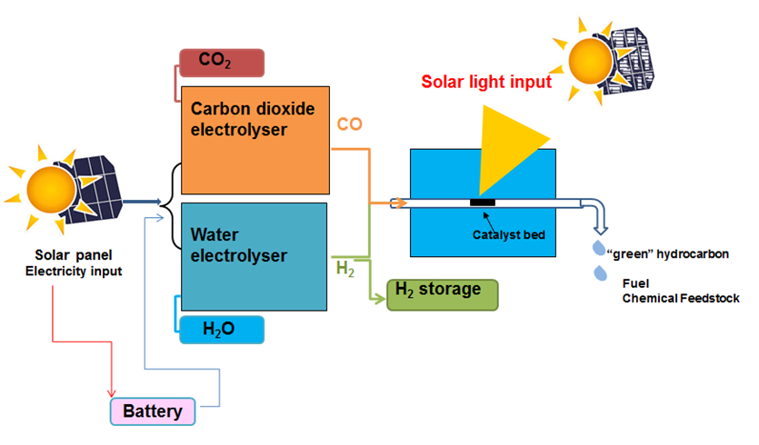
Fig. 1 Harnessing Solar Energy through electrocatalysis and photo-thermal catalysis to convert CO₂ and H₂O to Fuel and Chemical Feedstock.

