Understanding the formation and dynamic nature of non-noble-metal oxide co-catalysts for photocatalytic water splitting reactions

Jasmin Schubert, Janko Popovic, Andreas Lechner, Tushar Gupta, Sreejith P. Nandan, Ariane Giesriegl, Jia Wang, Greta Haselmann, Dominik Eder, Alexey Cherevan
Institute of Materials Chemistry, Vienna University of Technology, Vienna, Austria

Photocatalytic water splitting has been recognised by the community as a promising way to produce molecular H₂ from abundant water. The reaction of water splitting is, however, a rather challenging one and requires careful design of the catalytic sites for both, water oxidation (OER) and hydrogen evolution (HER), in order to become a viable alternative to existing ways of H₂ generation. The currently most efficient co-catalysts for the photocatalytic reduction and oxidation of water are Pt and Pd as well as IrO₂ and RuO₂, respectively: all are expensive materials based on rare noble metals. To achieve large scale industrial application, the development of new co-catalysts based on cheap and widely available elements remains an important issue.
In this work [1], we systematically investigated a set of oxide-based co-catalysts featuring Mn, Cu, Co, Fe and Ni prepared using a common wet impregnation – thermal decomposition route directly on TiO₂ nanoparticles, used here as a model photoactive substrate (Figure 1a). We carefully characterized the systems with a combination of TGA, in situ XRD (Figure 1d), ATR-FTIR, Raman, PL and XPS as well as tested all generated MO_{x}-TiO₂ composites towards sacrificial HER and OER reactions using our home-built photocatalytic reactors with in situ data collection
Combined spectroscopic and structual analyses revealed strong differences in thermal evolution of the pure M(acac)_{x} compared to impregnated M(acac)_{x}-TiO₂ samples where the M precursor underwent decomposition at substantially lower temperatures, via different mechanism and often resulted in the formation of otherwise unstable MO_{x} species. The final state of the co-catalyst nanoparticles, however, could be controlled by optimizing the calicnation conditions. Further SEM and TEM analyses along with EDX mappings confirmed the morphology of the generated MO_{x}-TiO₂ samples featuring small (2-5 nm) amorphous MO_{x} co-catalysts nanoparticles decorating the TiO₂ surface (Figure 1b), while spectroscopic methods provided in-depth information about the interactions between the composite components.
Finally, our water splitting tests indicated the dynamic nature of the NiO_{x}-TiO₂ and CuO_{x}-TiO₂ composites – both active towards HER – that undergo reversable in situ reduction during the photocatalytic cycle (Figure 1c). On the other hand, we found that FeO_{x}-TiO₂ and CoO_{x}-TiO₂ composites exhibited the highest OER activity compared to the bare TiO₂, while XPS data of the samples after reaction indicated that partial oxidation of M species took place during the course of the photocatalytic experiments.
This contribution provides a systematic study on the specifics of the wet chemistry-based synthesis of small MO_{x} NPs directly onto the surface of TiO₂, which can be expanded to other inorganic substrates, and thus will be of interest to the broad audience of materials scientists and chemical engeneers.
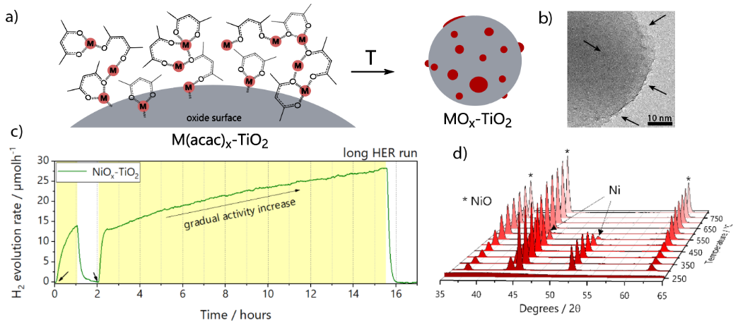

References
1. Schubert, J., Popovic J., Haselmann G., Nandan S., Wang J., Giesriegl A., Cherevan A. and Eder D. (2019). Immobilization of Co, Mn, Ni and Fe oxide co-catalysts on TiO₂ for photocatalytic water splitting reactions. J. Mater. Chem. A, 7, 18568–18579.

