Specific and sensitive nanoparticle-based electrochemical detection of Botrytis cinerea, a damaging fungal plant pathogen
Rebecca Ford^{A}, Marzia Bilkiss^{A}, Mostafa kamal Masud^{C}, Prabhakaran Sambasivan^{A}, Ido bar^{A}, Muhammad J.A. Shiddiky^{B}
^{A}Environmental Futures Research Institute, School of Environment and Science, Griffith University, Nathan Campus, QLD 4111, Australia.
^{B}Queensland Micro- and Nanotechnology Centre, Griffith University, Nathan Campus, QLD 4111, Australia.
^{C}Australian Institute for Bioengineering and Nanotechnology, University of Queensland, QLD 4072, Australia.

Introduction
Botrytis grey mould, caused by Botrytis cinerea, substantially reduces crop yields during environmentally conducive seasons. Greater success in application of Integrated Disease Management approaches to reduce loss would result from fast, accurate and cost-effective diagnosis and quantification of the causal pathogen. The existing immunogenic and molecular probe-type diagnostic methods are based on whole genome sequencing, PCR amplification or antibodies, are time consuming and offer varying levels of specificity and/or sensitivity (1).

Aims
As an alternative to current isothermal molecular diagnostic assays for B. cinerea, we aim to develop a portable diagnostic assay comprising species-specific molecular biosensors for detection and quantification of the mycelium and spore-derived nucleic acid of the target pathogen.

Methods
For this, sensitive and unique Botrytis cinerea probes were designed through multiple genome sequence alignment of isolates representing the Australian B. cinerea population on temperate legumes (chickpea and lentil) and also with alignment of NA sequences from within online databases. These were initially validated via traditional PCR in pure fungal and inoculated plant backgrounds for testing specificity and subsequently for sensitivity via quantitative PCR. Next, electro-catalytic assays were developed using functionalized magnetic nanoparticles. For this, a titration was established to determine the detection threshold with pure fungal DNA (Figure 1) and then the fungus was detected within plants previously inoculated with the fungus following a crude extraction process (Figure 2).

Results and discussion
The nanoparticle-based biosensor was extremely sensitive, able to detect a single spore within a raw total plant nucleic acid extract background and within 30 minutes at the in-field site. Translation of this technology to the field will enable quantitative assessment of pathogen load for future real-time accurate decision support for informed disease management
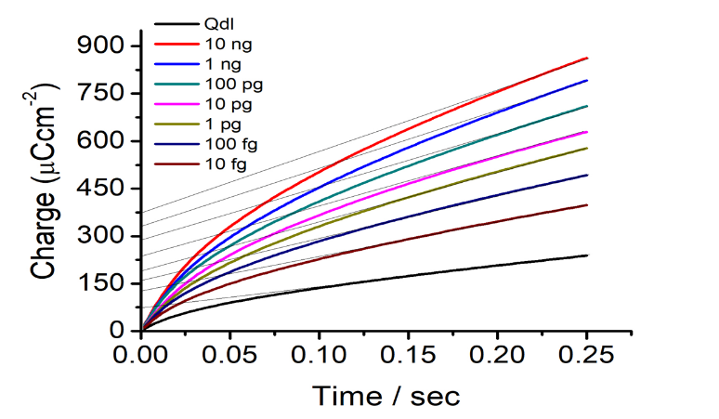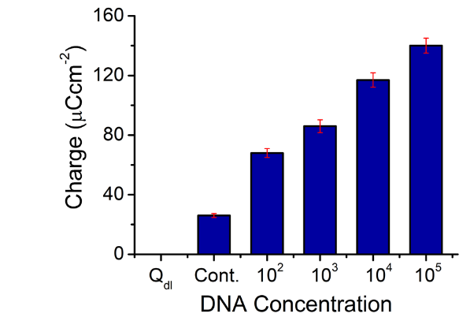
Figure 2
Figure 1
1. Bilkiss, M., Muhammad, S.J.A. & Ford, R. (2019). The new age of informed BGM disease management for temperate grain legumes - biosensors for fast, accurate and sensitive Botrytis species diagnostics. Front. Micro. 10, 1889.

