Strong electric control of a single hole g-factor
S. D. Liles¹, F. Martins¹, D. S. Miserev,^{1,2} I. D. Thorvaldson¹, M. Rendell¹, I. K. Jin¹, F. E. Hudson³, M. Veldhorst⁴, O. P. Sushkov¹, A. S. Dzurak³, A. R. Hamilton¹

¹School of Physics, University of New South Wales, Sydney NSW 2052, Australia; ²Department of Physics, University of Basel, Klingelbergstrasse 82, CH-4056 Basel, Switzerland; ³Centre for Quantum Computation and Communication Technology, School of Electrical Engineering and Telecommunications, The University of New South Wales, Sydney NSW 2052, Australia; ⁴ QuTech and Kavli Institute of Nanoscience, TU Delft, 2600 GA Delft, The Netherlands.

Hole spins in silicon quantum dots are attracting significant attention for their potential use as fast, highly coherent spin qubits [1]. However, there are still fundamental gaps in the understanding of the underlying physics of hole spins. For example, the full effects of electric confinement and spin-orbit coupling on hole spin states remains an open problem. Studies of the g-factor anisotropy are valuable for characterizing the underlying physics of a spin state. However, since the effect of spin-orbit coupling on holes is often complex [2], studies of a single hole in a known charge occupation provide valuable insight into the spin physics.
In this work [3], we use a 3D vector magnet to characterize the full g-factor anisotropy of one hole confined in a silicon MOS quantum dot [4]. We compare the g-factor anisotropy for different electric confinement profiles and find that the effective g-factor can be tuned over a large range, with values from 0.2 to 4. In addition, the orientation of the principal axes of the g-factor can be rotated by 30 degrees for a change in voltage of just 200mV. These results show that the strong anisotropy of the single hole g-factor is due to symmetries of orbital confinement, making silicon-based holes a promising system for fast all electric spin manipulation.
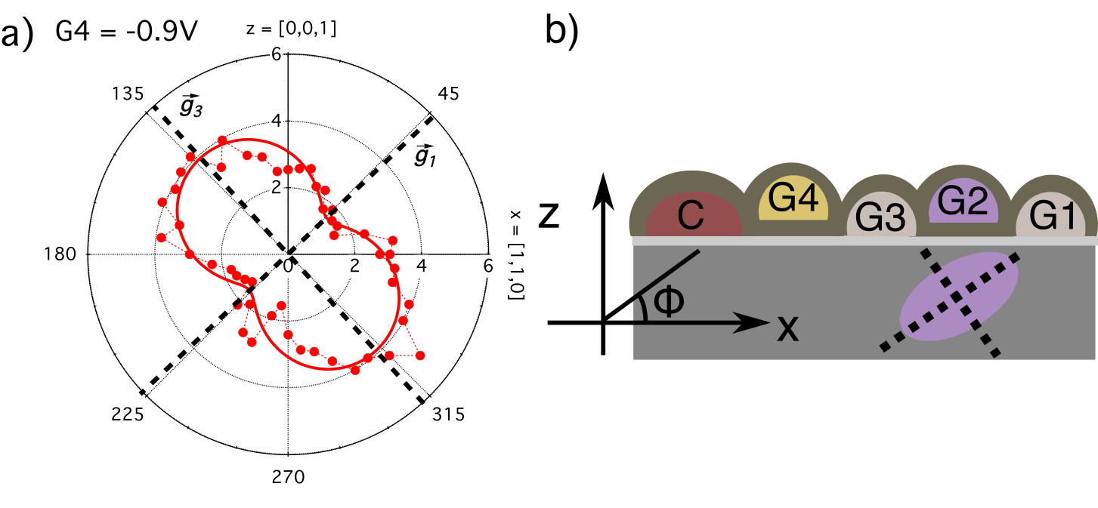
Figure 1: g-factor anisotropy for a single hole quantum dot: (a) Shows the effective g-factor (radial axis) as a function of magnetic field orientation in the x-z plane. The solid dashed lines indicate the direction of the principle magnetic axis. (b) Show a schematic of the sample x-z plane. A single quantum dot is formed under G2 and is confined by G1 and G3. We can determine the orientation of the quantum dot based on the orientation of the principle magnetic axes, as shown by the dashed black lines.

References
[1] C. Kloeffel et al., Phys. Rev. B 88, 241405 (2013)
[2] A. Crippa et al., Phys. Rev. Lett. 120, 137702 (2018)
[3] Publication in preparation.
[4] S. D. Liles et al., Nature Communications 9 (2018)

