Polarization dependent quantum correlation measurements of two single photon emitters

Davin Yue Ming Peng^{A,*}, Josef G. Worboys^{A}, Marco Capelli^{A}, Philipp Reineck^{A}, Brant C. Gibson^{A}, Andrew D. Greentree^{A}

^{A}Australian Research Council Centre of Excellence For Nanoscale Biophotonics, RMIT University, Melbourne, VIC 3001, Australia

Quantum correlation measurements provide qualitatively different insight into the properties of fluorophores than afforded by classical intensity measurements alone. Here we focus on the second order correlation function ($g_{2}^{\left(2\right)}\left(τ\right)$) of two single-photon active fluorophores in one point spread function as a function of emission polarization. We use the Hanbury Brown and Twiss setup to measure the correlations between photon arrival times on two single photon avalanche detectors. The fluorophores considered in this study were nitrogen vacancy color centres in nanodiamonds.
By rotating the output polarizer, we change the relative intensities received from the two emitters. The general form of $g_{2}^{\left(2\right)}\left(0\right)$ is
$g_{2}^{\left(2\right)}\left(0\right)=\frac{2α}{{(1+α)}^{2}}$,
where $α$ is the ratio of the received intensities from emitter 1 and emitter 2. Fig. 1a shows the variation of $g_{2}^{\left(2\right)}\left(τ\right)$ for two polarizations $θ=40°$ and $130°$. Fig. 1b shows the emission intensity as a function of polarization angle and can be fitted with two emitters with different orientations and relative brightness. Fig. 1c reveals the correlation function of the two emitters when changing the polarization collected. These results highlight the novel information gained about the fluorophores and pave the way for future protocols in particle localization and characterization in quantum imaging.

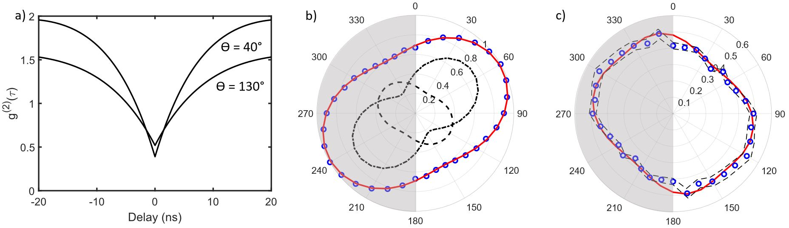

Fig. 1. (a) $g_{2}^{\left(2\right)}\left(τ\right)$ for two polarizations $θ=40°$ and $130°.$(b) Polarization plot of measured fluorescence intensity (circles) together with the fit of two emitters (solid curve). The relative orientation of the emitters was reconstructed using the emission of each single-photon emitters (dashed lines). (c) Predicted $g_{2}^{\left(2\right)}\left(0\right)$ value (solid curve) plotted with the experimental data (circles) against emission polarization angle. Data were measured from $0°$ to $180°$and repeated for $180°$ to $360°$ at 500 μW.

References
- Worboys, J.G., D.W. Drumm, and A.D. Greentree. 2018, arXiv:1810.01712 [quant-ph]
- D. Gatto Monticone, K. Katamadze, P. Traina, E. Moreva, J. Forneris, I. Ruo-Berchera, P. Olivero, I. P. Degiovanni, G. Brida, and M. Genovese, Phys. Rev. Lett. 113, 143602 (2014).
- O. Schwartz, J. M. Levitt, R. Tenne, S. Itzhakov, Z. Deutsch, and D. Oron, Nano Lett. 13, 5832, 2013.

*davin.yue.ming.peng@student.rmit.edu.au

