Erasable and recreatable two-dimensional electron gas at the heterointerface of SrTiO₃ and a water-dissolvable overlayer

Xiao Renshaw Wang

^{A}School of Physical and Mathematical Sciences & School of Electrical and Electronic Engineering, Nanyang Technological University, Singapore 637371

Introduction
With the unprecedented advances in the material fabrication, oxide-based heterostructures and superlattices can now be synthesized with superior crystallinity and atomic abruptness. These high-quality interfaces provide an ideal platform for the investigation and utilization of the interfacial interplays of charge, spin, lattice, and orbit. For instance, the emergent while unexpected interfacial effects, such as two-dimensional electron gas (2DEG) [1,2], were discovered.
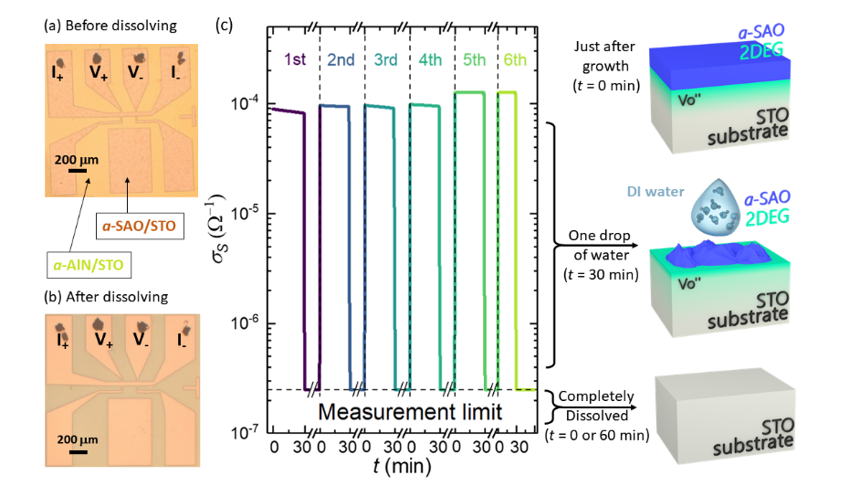
Results
In this talk, I will present one of our recent studies, where we demonstrated an erasable and recreatable 2DEG at an interface between an amorphous Sr₃Al₂O₆ (a-SAO) overlayer and a single crystalline SrTiO₃ (STO) substrate [3]. As shown in the figure, by depositing or removing the a-SAO at room temperature in a facile room temperature process, the 2DEG in the oxide heterostructure can be recreated or erased, respectively. 20 nm a-SAO/STO (001) heterointerface with a Hall bar pattern (a) before and (b) after the a-SAO overlayer dissolving into the DI water. Time dependence of sheet conductance at 300 K in ambient condition for 20 nm a-SAO/STO (001). The vertical dash lines indicate that a drop of water is added on the Hall bar device, the horizontal dash line indicates the measurement limit. The right panels schematically illustrated the three states of the electronic device: (top) metallic just after growth (at each t = 0 min), (middle) a fast metal-to-insulator transition with one drop of DI water added on the device (at each t = 30 min), and (bottom) becoming insulating after the a-SAO fully dissolved into the DI water (at each 30 min < t < 60 or 0 min). Furthermore, in the process of removing the a-SAO, an additional transition of nonlinear to linear Hall resistance is also observed, demonstrating two types of carriers in the oxide heterostructure. I will discuss the origin of the 2DEG and also the impact of the dielectric properties of the STO onto the 2DEG.
Conclusion
We believe the water-dissolvable 2DEG with an advantage of room-temperature erasing, creation and patterning processes could inspire an approach for realizing the highly demanded environment-friendly and recyclable electronic devices in a facile and scalable manner. Furthermore, the physics involved in the 2DEG also provides insights into the properties of STO surface and related 2DEG.
References
- Ohtomo, A., Muller, D. A., Grazul, J. L. & Hwang, H. Y. (2002). Artificial charge-modulation in atomic-scale perovskite titanate superlattices. Nature 419, 378–380.
- Ohtomo, A. & Hwang, H. Y. (2004). A high-mobility electron gas at the LaAlO₃/SrTiO₃ heterointerface. Nature 427, 423–426.
- K. Han, K. G. Hu, X. Li, K. Huang, Z. Huang, S. W. Zeng, D. C. Qi, C. Ye, J. Yang, H. Xu, A. Ariando, J. B. Yi, W. M. Lü, S. S. Yan, and X. Renshaw Wang. (2019). Erasable and recreatable two-dimensional electron gas at the heterointerface of SrTiO₃ and a water-dissolvable overlayer, Science Advance 5, eaaw7286.

