Diffraction unlimited imaging: multilateration localization of two single-photon fluorophores

Josef G Worboys^{A}, Daniel W. Drumm^{A}, Andrew D Greentree^{A}

^{A}Australian Research Council Centre of Excellence for Nanoscale BioPhotonics, RMIT, Melbourne, Australia

Imaging below the diffraction limit has been achieved through superresolution microscopy techniques (e.g. STED) [1]. However, high phototoxicity levels can be invasive and therefore potentially devastating to living cells [2]. Recently, quantum correlations have been used to increase sub-wavelength imaging using cross-correlation functions in both confocal [3] and widefield imaging modalities [4]. Cross-correlation functions utilize the Hanbury Brown & Twiss apparatus which was originally designed to measure the angular diameter of stars [5], but since has been adopted to microscopy.
We investigate a diffraction unlimited protocol for ascertaining the minimum measurements required for localizing particles in the sub-wavelength regime using cross-correlation functions [6]. Our protocol is based on the concept of geometric trilateration predominantly used in aeronautics, crystallography, and surveying [7-9].
We endeavour to determine via multilateration the optimal number of measurement locations on a given circle. We first look at the scaling between three and twelve measurement sites as shown in Fig. 1 (d) where the linear fits show enhanced localization precision with the order of lateration.

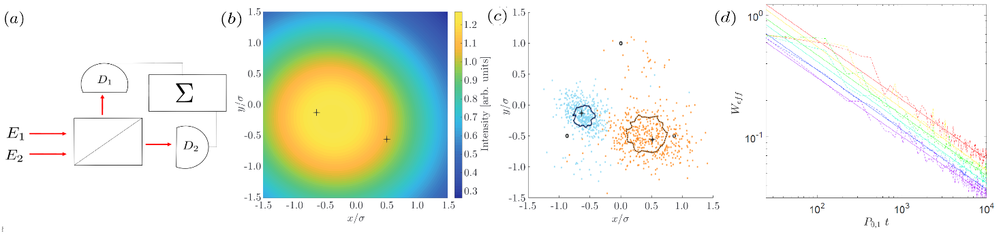
Fig. 1. (a) Simplified depiction for a typical Hanbury Brown and Twiss (HBT) apparatus with two detectors (D₁,D₂) for two single-photon emitters (E₁,E₂). (b) Imaging for two single-photon emitters shown by the plus symbols accompanied by pseudocolor plot depicting predicted confocal map for a single detector. Simulation is scanned over both emitters showing both emitters are incapable of being resolved classically. (c) Simulation reconstruction from 501 independent trilateration sequence. Where the black open circles are the measurement locations each having individual HBT apparatus from (a). The blue and orange dots depict the inferred locations given the simulated measurements and analysis per location. The black contours give the error radius based on the effective point spread function width (W_{eff}). (d) Multilateration scaling for 3,4,5,6,9 and 12 (red - purple) detector measurement locations. Linear fits of respective color show $1/\sqrt{t}$ scaling with localization precision.

The authors acknowledge the support of the ARC Centre of Excellence for Nanoscale BioPhotonics (Grant No. CE140100003), JGW and ADG acknowledge the support of an ARC Future Fellowship (Grant No. FT160100357) and RMIT for scholarship funding. This research was undertaken with the assistance of resources from the National Computing Infrastructure (NCI) supported by (LE160100051).
References
- Hell, S.W, Wichmann, J, Opt.Lett. 19, 780, (1994).
- Nat. Methods, vol. 15, no. 10, p. 751, (2018).
- Monticone, D.G et al., Phys. Rev. Lett. 113, 143602 (2014).
- Schwartz, J.M et al., Nano Lett. 13, 5832, (2013).
- Hanbury, R, Twiss, R.Q., Nature 178, 1046 (1956).
- Worboys, J.G., Drumm,D.W., and Greentree, A.D. arXiv:1810.01712v2 (2018).
- Manolakis, D.E., IEEE Trans. Aerosp. Electron. Syst. Vol. 32, pp. 1239-1248, (1996).
- Mackay, A.L., Acta Crystalographica, vol. A-30, pp. 440-447 (1974).
- Kjaergaard, M.B, et al., Pervasive computing, pp.38 (2010).
Corresponding Author: josefgworboys@gmail.com

