Rechargeable Aluminum-Selenium Batteries
Xiaodan Huang^{A}, Chengzhong Yu^{A}
^{A} Australian Institute for Bioengineering and Nanotechnology, The University of Queensland, St Lucia, QLD 4072, Australia
E-mail: x.huang@uq.edu.au

Developing next-generation rechargeable batteries with high energy density, low cost, and improved safety is essential for a sustainable energy future. Rechargeable Al-ion batteries have attracted great research interests as a promising post lithium-ion battery technology, due to the high theoretical capacity (2980 mAh g⁻¹ and 8040 mAh cm⁻³), high natural abundance and high safety profile of Al. The major challenge for the development of Al-ion batteries lies in the cathode. A broad range of cathode materials including metal oxides, metal sulfides, MXene, conductive polymers, and microporous carbon, have been investigated, but show relatively low discharge potential (<1.0 V), low discharge capacity or capacitive behaviours. Graphitic carbon materials are currently the most promising cathodes, presenting a high discharge voltage and long cycling life. However, their charge storage capabilities are limited by the inherent intercalation mechanism with relatively low specific capacities between 60 and 150 mAh g⁻¹. Herein, have demonstrated the first design of rechargeable Al-Se battery. A new strategy to stabilize the liquid charge product in Al-Se cells is introduced. By creatively using mesoporous carbon and Se nanowire as the composite cathode, this new rechargeable battery is powered by the reversible redox reaction of Se₂Cl₂/Se pair occurs in the confined carbon mesopores. With the assist of mesoporous carbon, Se nanowires can deliver high reversible capacities with high discharge voltage and good cycling/rate stability. The new rechargeable battery and the scientific insights obtained in this research open a new avenue for the development of high-performance post lithium-ion battery technologies.

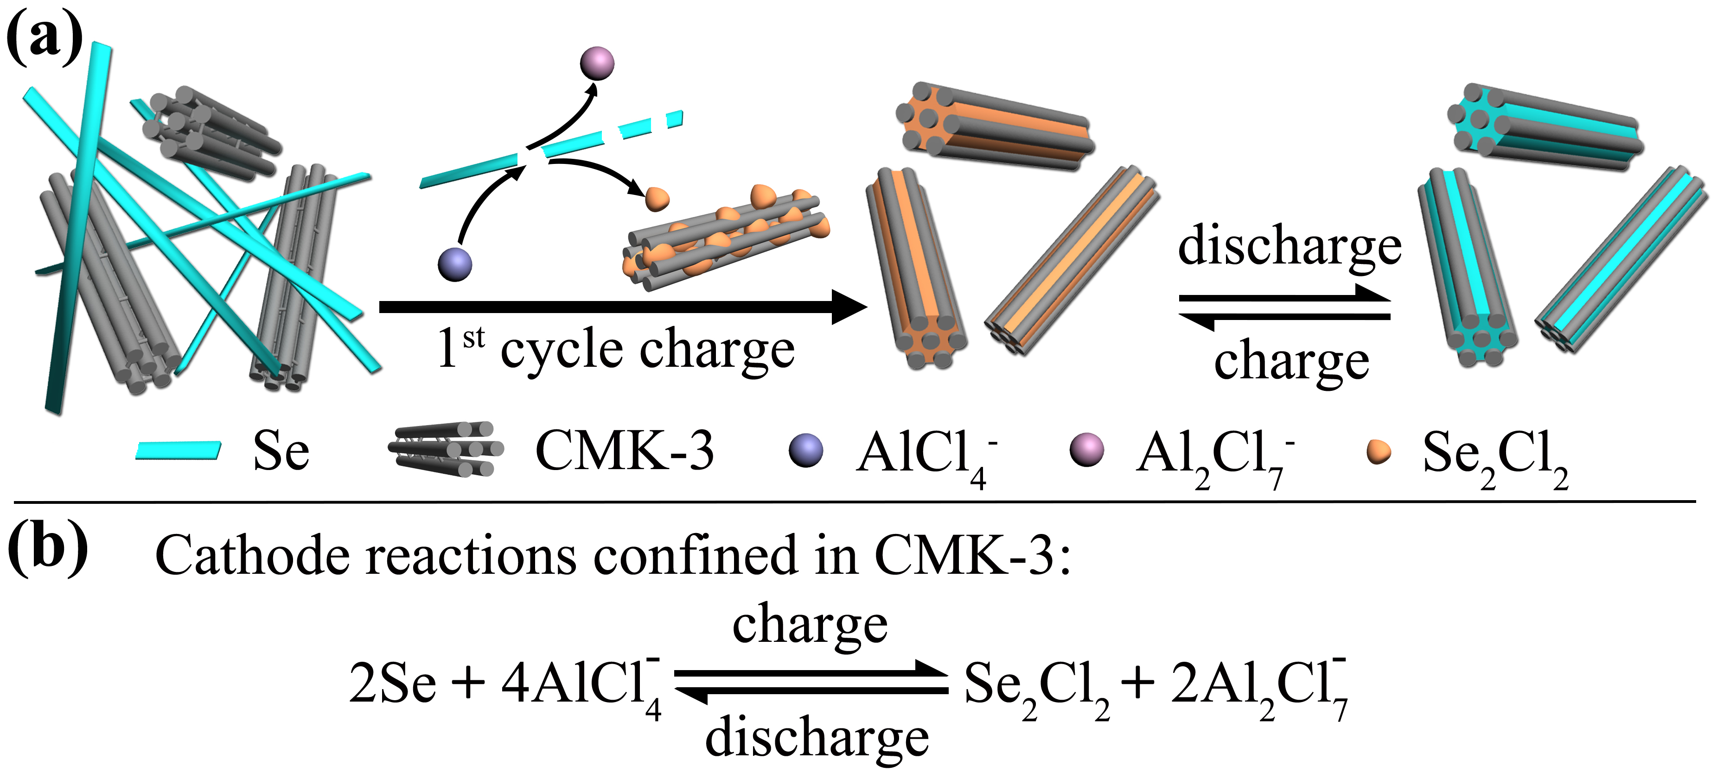

Figure 1. (a) Schematic illustration of the proposed mechanism for Al-Se batteries using Se nanowires and mesoporous carbon composite cathodes. (b) The proposed reversible reaction of Se cathode.

References
- Huang X. D., Liu Y., Liu C., Zhang J., Noonan O. and Yu C. Z. Rechargeable aluminum–selenium batteries with high capacity, Chem. Sci., 9, 5178–5182, 2018.

