Interplay of Aharonov-Bohm interference and signatures of Majorana fermions

T.C. Bartolo^{A}, J.S. Smith^{A}, C. Müller^{B}, T.M. Stace^{B}, B. Muralidharan^{C}, J. H. Cole^{A}
^{A}Chemical and Quantum Physics, School of Science, RMIT University, Melbourne, Australia
^{B}ARC Centre of Excellence for Engineered Quantum Systems (EQUS), School of Mathematics and Physics, University of Queensland, Brisbane, 4072, Australia
^{C}Department of Electrical Engineering, IIT Bombay, Powai, Mumbai-400076, India

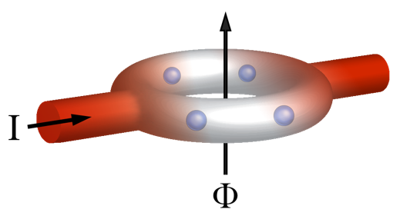
Majorana fermions (MFs) are a theoretical particle which, unlike conventional fermions, act as their own antiparticle. The non-abelian nature of these particles means than the physical action of braiding one MF around another imparts a non-trivial phase. Recently a condensed matter realisation of these particles was suggested by Kitaev whereby MFs would exist at the ends of superconducting nanowires¹. Encoding information in such a system would be topologically protected from noise, as a global perturbation would be required to destroy the stored information. Systems with such a topological protection are therefore highly sought after for computing and information storage purposes².
Figure 1. Semiconducting ring with two Kitaev chains embedded within (white). Each Kitaev chain hosts one Majorana fermion at each of its ends (blue spheres). A magnetic field (Φ) is applied perpendicularly to this ring and a current (I) is passed through the ring.

The primary signature of the existence of MFs in superconducting nanowires is a zero bias conductance (ZBC) feature in the transport response of the wires. There have thus far been several experiments which produce signatures of Majorana bound states (MBS)^{3,4}. However there are several alternative explanations for such a feature which can cast doubt over the origin of the ZBC observed in experiment. Alternative explanations include effects such as Andreev bound states and weak antilocalisation which can manifest sub-energy gap states that can be mistaken for the ZBC characteristic to MFs. It is therefore important to devise a method of distinguishing systems which definitively contain MBS from other topologically trivial effects³. To this end we are exploring circuit geometries which are capable of hosting Majorana fermions at the superconducting/normal interfaces within the circuit. A computational model for these unique geometries allows us to study the interplay between MBS and the interference effects induced applied by magnetic fields.

We begin by computationally examining a ring comprised of two Kitaev chains with a normal conducting links between them (see Fig. 1), where the MFs form at the normal/superconducting interfaces. MFs from neighbouring Kitaev chains in the ring may interact and hybridize as a function of their separation. Consequently, we compute transport signatures as a function of ring dimensions to study how MFs in this geometry interact. Further, an applied magnetic field induces Aharonov-Bohm interference due to path differences around the ring⁵. This allows for an analysis of signatures of MFs as a function of the magnitude and direction of an applied magnetic field. This computational model can inform future experiments which probe the topological properties of Majorana fermions.

References
- Kitaev, A. Y. Unpaired Majorana fermions in quantum wires. Physics-Uspekhi 44, 131–136 (2001).
- Hasan, M. Z. & Kane, C. L. Colloquium : Topological insulators. Rev. Mod. Phys. 82, 3045–3067 (2010).
- Mourik, V. et al. Signatures of Majorana fermions in hybrid superconductor-semiconductor nanowire devices. Science 336, 1003–7 (2012).
- Rokhinson, L. P., Liu, X. & Furdyna, J. K. The fractional a.c. Josephson effect in a semiconductor–superconductor nanowire as a signature of Majorana particles. Nat. Phys. 8, 795–799 (2012).
- Aharonov, Y. & Bohm, D. Further Considerations on Electromagnetic Potentials in the Quantum Theory. Phys. Rev. 123, 1511–1524 (1961).

