Unravelling the microstructure of multi-cation mixed halide perovskites

Huyen T. Pham^{A}, The Duong^{B}, William D. A. Rickard^{C}, Klaus J. Weber^{B}, Jennifer Wong-Leung^{A}

^{A}Department of Electronic Materials Engineering, Research School of Physics, Australian National University, Canberra, ACT2601, Australia; ^{B}Research School of Electrical, Energy and Materials Engineering, ANU, Canberra, ACT 2601, Australia; ^{C}John de Laeter Centre, Curtin University, Perth, WA 6102, Australia

Semiconductor characterisation is integral to understanding the performance of devices for photovoltaic and optoelectronic applications. In this presentation, we will focus on the microstructure analyses of multiple cation mixed halide perovskites thin film.
Perovskite materials have become the most promising photovoltaic materials as the main absorber layer in solar cells, either as single cells or in tandem with silicon solar cells. There are many challenges in particular for the methyl ammonium lead iodide or MAPbI₃ materials due to their easy degradation under light, air, moisture and electron beam. Consequently, other mixed halide perovskites materials have been considered with the alloying of organic components such as formamidinium (FA) and inorganic metals such as Rb and Cs for the cation A sites and different halides such as Br and Cl for the anion X sites. In addition, the perovskite crystal structures can vary from cubic structure (untilted PbI₆ octahedra) to tetragonal and orthorhombic structures (tilted octahedra). We will present our recent electron microscopy analyses on mixed halide perovskites crystal structures with electron diffraction and simulations (Figure 1). Focused ion beam (FIB) combined with time of flight secondary ion mass spectrometry (ToF-SIMS) was used to identify the nature of Rb and Cs incorporation within the crystal grains. The chemical composition was determined combining both FIB ToF-SIMS and energy dispersive X-ray Spectrometry (EDS) analyses in scanning transmission electron microscopy (STEM) mode. Distinct segregation of the Rb in Rb rich phase was observed while the Cs was uniformly incorporated throughout the layer.

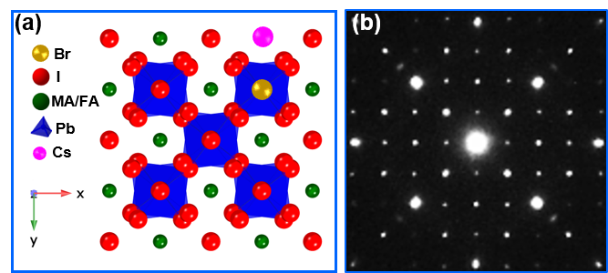
Figure 1 (a) atomic structure model and (b) experimental selected area electron diffraction pattern of multiple mixed halide perovskites.

