Gas phase water splitting of moisture in ambient air: toward cost-free inputs for hydrogen production

Cameron J. Shearer,^{A} Takashi Hisatomi,^{B} Kazunari Domen,^{C} Gregory F. Metha^{A}

^{A}Department of Chemistry, The University of Adelaide, Adelaide, Australia. ^{B}Research Initiative for Supra-Materials (RISM), Shinshu University, Japan. ^{C}Department of Chemical Engineering, The University of Tokyo, Japan.
Abstract
Hydrogen is a portable, renewable and non-polluting fuel source that can be produced via the splitting of water (H₂O) to create hydrogen (H₂) and oxygen (O₂). Photocatalytic water splitting uses a catalyst excited by light to drive the hydrogen and oxygen evolution reactions. Photocatalysis with sunlight and water as the only inputs has the capability of hydrogen generation in mobile and remote (off-grid) sites. Here we investigate the temperature and illumination limits of gas phase (non-condensing) water splitting. We use well-defined photocatalysts made up of Al-doped SrTiO₃ (SrTiO₃:Al) loaded with a RhCrO_{x} and CoO_{y} co-catalyst[1] in a batch phase reactor containing either water vapour dosed into N₂ bath gas or real air samples. The catalyst samples are deposited onto an inert substrate and irradiated under variable intensity UV LED.[2, 3] Both hydrogen and oxygen are produced in approximately 2:1 stoichiometric ratio over a duration of 6 hours (Figure 1). The production rates are found to be highly sensitive to the water vapour concentration and temperate of the reactor, as has been found previously for GaN:ZnO photocatalysts.[4] We also find that the production rate increases with light intensity up to a certain amount, which is due to a limitation in availability of reactant. Importantly, the back reaction of H₂O formation from H₂ and O₂ gas is supressed, even in air which is a high O₂ environment. These results show that photocatalysis is a promising route for power generation in remote sites without access to electricity or pure water.

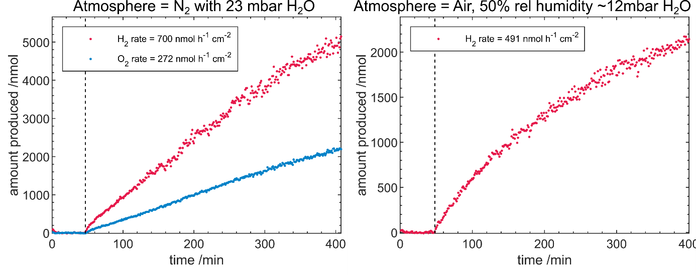
Figure 1: Gas phase photocatalytic water splitting using SrTiO₃:Al with RhCrO_{x} and CoO_{y} under (left) simulated 100% humidity air using nitrogen and water vapour (23mbar); and (right) ambient air with 50% humidity ~12mbar H₂O (O₂ not shown). Both experiments illuminated with UV-LED light (14.3 mW/cm²) with reaction at 1 bar and 30ºC. Dashed vertical line indicates when UV light was switched on.
References
1. Goto, Y., et al., A Particulate Photocatalyst Water-Splitting Panel for Large-Scale Solar Hydrogen Generation. Joule, 2018. 2(3): p. 509-520.
2. Shearer, C., et al., Pt Nanocluster Co-Catalysts for Photocatalytic Water Splitting. C, 2018. 4(4): p. 64.
3. Alvino, J.F., et al., Apparatus for the investigation of high-temperature, high-pressure gas-phase heterogeneous catalytic and photo-catalytic materials. Review of Scientific Instruments, 2017. 88(5).
4. Dionigi, F., et al., Gas phase photocatalytic water splitting with Rh2−yCryO3/GaN:ZnO in μ-reactors. Energy & Environmental Science, 2011. 4(8): p. 2937-2942.

