Coexisting structural phases in the catalytically driven growth of rock salt GdN

Ali Shaib^{A}*, Franck Natali^{A}, Jay R Chan^{A}, Felicia Ullstad^{A}, William F Holmes-Hewett^{A}, Jackson D Miller^{A}, Ben J Ruck^{A}, Harry J Trodahl^{A}

^{A}The MacDiarmid Institute for Advanced Materials and Nanotechnology, School of Chemical and Physical Sciences, Victoria University of Wellington, PO Box 600, Wellington, New Zealand.
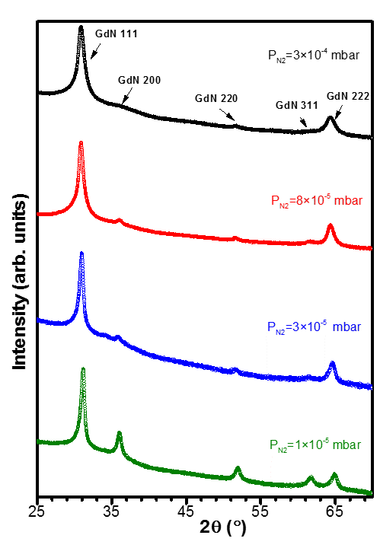
Introduction
Interest in rare earth mononitride (REN) compounds has immensely increased owing to their potential to offer an alternative to dilute magnetic semiconductors. Most of the RENs share the unique combination of intrinsic ferromagnetic and semiconducting properties providing an opportunity to build a new generation of spintronics devices^{1,2}. Future exploitation of these materials necessitates the understanding of the growth mechanisms and parameters controlling the structural, electrical, and magnetic properties of the REN compounds.
Aims
Our work aims to investigate the role of nitrogen vacancies (V_{N}) in polycrystalline thin films of the rock salt GdN, the prototypical REN. This work explores the formation of a secondary GdN phase associated to the V_{N} level in the film (GdN-II), and its coexistence with the near-stoichiometric “intrinsic” GdN phase (GdN-I) through investigating the structural, electrical, and magnetic properties of GdN films grown with different V_{N} levels.
Fig. 1. 2θ-θ XRD diffractograms of GdN thin films grown under N₂ pressure of 1x10⁻⁵, 3x10⁻⁵, 8x10⁻⁵ and 3x10⁻⁴ mbar
Methods
Gd metal was deposited with an electron gun on fused silica in the presence of molecular nitrogen (N₂) partial pressure ranging between 1×10⁻⁵ and 3×10⁻⁴ mbar. N₂ reacts spontaneously with Gd at the surface to form a GdN layer, even in the absence of activated N₂. X-ray diffraction (XRD) scans and Raman spectra were used to characterize the crystallographic properties. Resistivity and Hall effect measurements were performed at ambient temperature, and the magnetic properties of the films were investigated down to 4 K.
Results and conclusion
We studied the correlation between the structural, electrical, and magnetic properties of the catalytically driven growth of GdN. XRD measurements display a strong (111) preferential orientation for all N₂ pressures and the signature of a secondary phase of GdN (GdN-II) with a smaller lattice constant that develops with the increase of N-deficient regions (Fig. 1). Raman spectra, electrical and magnetic results support correlating this GdN-II phase to V_{N}. Simultaneously, we observe an increase of the Curie temperature with the higher V_{N} levels, i.e., lower N₂ growth pressure, with results emphasizing the soft ferromagnetic nature of GdN-II. In conclusion, this work reports key aspects of the growth of polycrystalline GdN thin films of importance for the exploitation of the RENs, including preferential growth and the coexistence of two (111)-oriented phases supported by X-ray diffraction measurements, Raman spectroscopy, and electrical and magnetic measurements.
References
- Natali, F. et al. (2013). Rare-earth mononitrides. Prog. Mats. Sci. 58(8), 1316-1360.
- Awschalom, D.D. & Flatté, M.E. (2007). Challenges for semiconductor spintronics. Nature Physics 3(3), 153.
*Corresponding author’s email: ali.shaib@vuw.ac.nz

