New intercalation cathodes for aluminium-ion batteries

Shalini Divya^{A}, Thomas Nann^{B}
^{A}School of Chemical and Physical Sciences, Victoria University of Wellington, Wellington, New Zealand; ^{B}School of Mathematical and Physical Sciences, University of Newcastle, Newcastle, Australia.
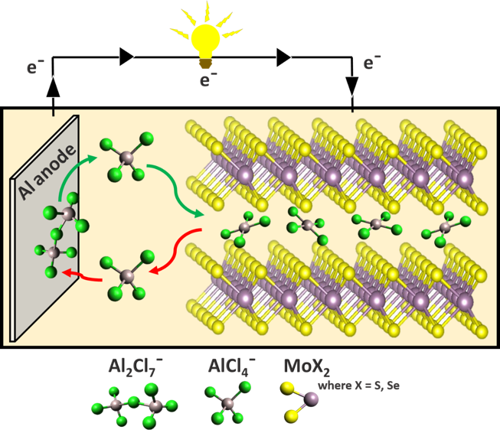
Figure 1: Schematic - aluminium-ion battery.
Lithium ion batteries (LIBs) are dominating the market due to their superior overall performance compared with other secondary battery types. However, lithium and cobalt – two of the main components in LIB electrodes – are not Earth abundant and LIB electrolytes are inflammable, occasionally causing ‘thermal runaway’. Aluminium is the third most abundant element in the Earth's crust, typical aluminium-ion battery (AIB) electrolytes are not flammable, and their theoretical performance may exceed that of LIBs. Recent improvements in these batteries have narrowed the gap in performance to LIBs and improved electrodes might close it completely.

Many successful battery electrodes are based on 2D-layered materials. We have studied aluminium-ion batteries using molybdenum dichalcogenides – MoS₂, MoSe₂ and MoSSe as active cathode materials. The batteries exhibited clear discharge voltage plateaus in the ranges 1.6 - 1.4 V for MoS₂ and MoSe₂, and 0.6 - 0.5 V for MoSSe. While the MoSSe cathode showed a higher specific capacity over MoS₂ and MoSe₂, the overall energy density was lower than MoSe₂ at a current density of 40 mA g⁻¹. MoSe₂ proved to be a more stable cathode with a discharge specific capacity of 110 mAh g⁻¹ with an average potential at approximately 2.0 V. Charge/discharge cycling at 100 mA g⁻¹ demonstrated the stability of Al/MoSe₂ cells over 200 cycles with 90% coulombic efficiency.

Overall, we found that different molybdenum dichalcogenides behaved surprisingly different when used as cathodes for AIBs. All electrodes showed a mixture between capacitive and faradayic energy storage, but only MoSe₂ displayed clear evidence for intercalation.

Correspondence: thomas.nann@newcastle.edu.au

