Modulating aptamer-NanoZyme (nanoparticles with enzyme-mimic catalytic activity) interactions for the development of colorimetric sensors

Vipul Bansal,^{A} Rajesh Ramanathan^{A},
^{A}Nanobiotechnology Research Laboratory, School of Science, RMIT University, GPO Box 2476, Melbourne, Victoria, Australia.
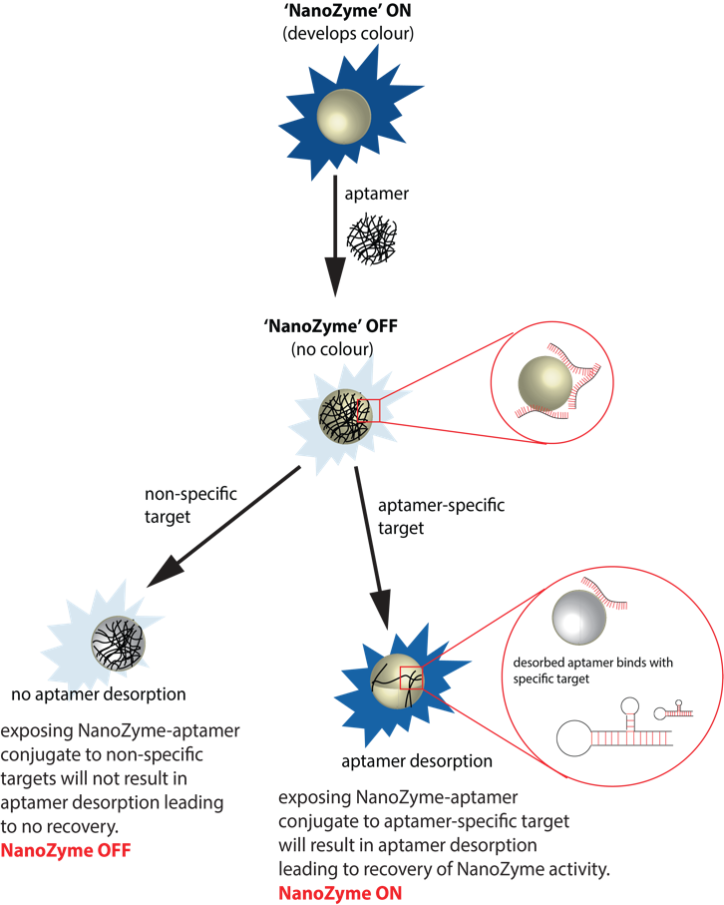

With limited efficiency of existing biosensors with respect to response time, selectivity and multiplexing, there is an unmet need to address these challenging problems. Of these challenges, the need for rapid and selective detection of compounds is increasingly important in aspects of food, agriculture, health and environmental monitoring. Recently, a number of nanomaterials are being discovered to behave similar to the traditional biomolecular enzymes such as peroxidase, oxidase, catalase and superoxide dismutase. This biomimetic activity of nanomaterials is establishing ‘nanozymes’ as artificial inorganic enzymes and the research field have just begun to explore this unique property for a range of applications.

Rapid and accurate identification of chemical and biological analytes in clinical, environmental and food is critical for clinical diagnosis, disease management, food safety and environmental monitoring. Given that treatment of several diseases is dependent on accurate detection of analytes, there is a strong focus on the development of biosensing platforms for rapid detection of different analytes.

We have established that by combining the nanozyme activity of different nanomaterials (e.g. metals, metal oxides, 2-D dichalcogenides) with molecular recognition elements (MREs) such as aptamers, the nanozyme activity can be actively modulated. This control over nanozyme activity of inorganic materials has allowed us to develop new ultrafast, highly sensitive and selective colorimetric sensors for the detection of a range of analyte molecules. This approach is generic and can be applied for the detection of a range of analyte molecules relevant to environmental monitoring as well as biomedical and food industries.

The concept is based on the inherent peroxidase-mimic activity of nanoparticles that produces a distinct color response in the presence of a substrate such as TMB, ABTS or OPD. The sensor probe fabrication occurs through the binding of target specific aptamers/lectins on to the nanozyme. The sensor either uses a a dynamic (turn-off/turn-on) or static approach (turn-on) strategy during detection. The intensity of the color is directly proportional to the amount of target thereby allowing us to not only qualitatively detect the analyte but also quantify. The generation of color is rapid and typically takes minutes, which makes the current technique viable for point-of-care device development.

References
- Weerathunge, P.; Ramanathan, R. et. al (2019). Ultrasensitive colorimetric detection of murine norovirus using NanoZyme aptasensor. Anal. Chem., 91, 3270-3276.
- Weerathunge, P.; Ramanathan, R. et. al (2014). Aptamer-controlled reversible inhibition of gold nanozyme activity for pesticide sensing. Anal. Chem., 86, 11937-11941.

