Vortex Fluidic Mediated Synthesis Polysulfone for Membrane Applications
Aghil Igder^{A}, Scott Pye^{B}, Ahmed Hussein Mohammed Al-Antaki^{B}, Alireza Keshavarz^{A}, Colin L. Raston^{B}, and Ata Nosrati^{A}
^{A}School of Engineering, Edith Cowan University, Perth, Australia; ^{B}Flinders Institute for Nanoscale Science and Technology (CNST), College of Science and Engineering, Flinders University, Adelaide, Australia.
Polysulfone (PSF) has been prepared in a Vortex Fluid Device (VFD) for the first time, for comparing its properties relative to the commercially available material. The synthesis involved varying the operating parameters of the microfluidic platform, namely rotational speed, temperature, and tilt angle and processing time for the confined mode operation. The molecular weight (M_{W}), glass transition temperature (T_{g}) and decomposition temperature of the polymer were using Gel Permeation Chromatography (GPC), Differential Scanning Calorimetry (DSC) and Thermal Gravimetric Analysis (TGA) respectively. The formation of PSF involved a two-step reaction process ^{[1]}. The processing takes advantage of the increase in heat dissipation and water evaporation in the thin film of liquid in the VFD. The PSF from VFD processing and conventional batch synthesis were compared in terms of M_{W}, T_{g}, and decomposition temperature. Finally, the optimal VFD prepared polymer had a M_{W} ~ 12000 g/mol, T_{g}= 168 °C and decomposition temperature of ~ 530 °C, which was formed at 6000 rpm rotational speed, 170 °C in 45° tilt angle, for 30 min reaction time, considerable less the conventional synthesis of PSF. The utility of the VFD prepare material in membrane technology will be presented, with preliminary results presented in Figure 2.
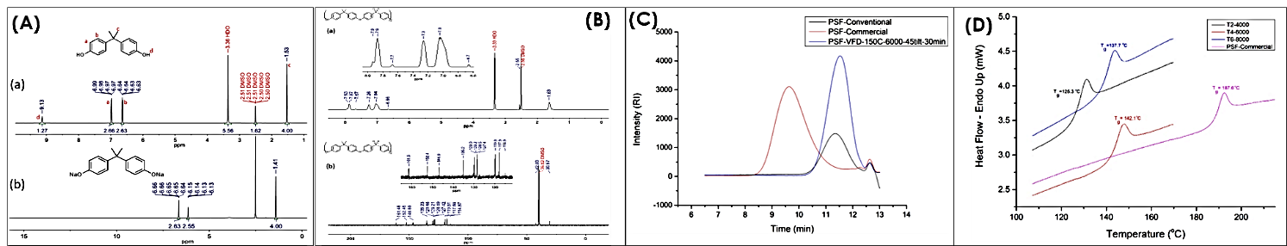
Figure 1. (A) HNMR of BPA and its DiNa salt, (B) H-NMR and C-NMR of PSF, (C) GPC curves with a refractive index detector (RI) for commercial, VFD and conventional synthesized PSFs, and (D) DSC thermograms of commercial and VFD synthesized PSFs were cycled from 10 °C to 230 °C at a rate of 10 °C min⁻¹.
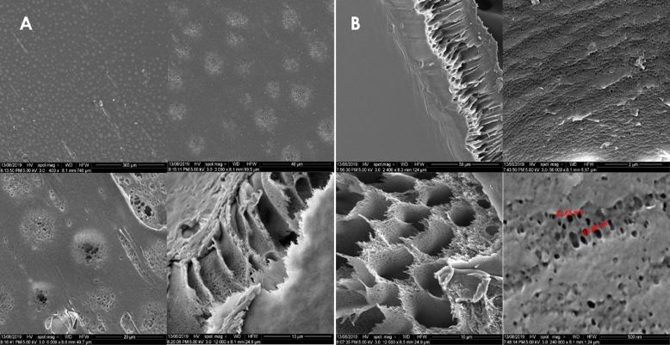
Figure 2. SEM images of Membranes fabricated in A) Batch processing B) VFD processing

References
1. Johnson, R.N., et al., Poly(ary1 Ethers) by Nucleophilic Aromatic Substitution. I. Synthesis and Properties. JOURNAL OF POLYMER SCIENCE: PART A-1, 1967. VOL. 5: p. 2375-2398.

