Electronic structure of fast-ion conducting alkali metal vanadium phosphates

Tristram Jenkins^{A}, Jose Alarco^{A}, Ian Mackinnon^{A}
^{A}Institute for Future Environments and Science and Engineering Faculty, Queensland University of Technology, Brisbane 4001 Australia

Introduction
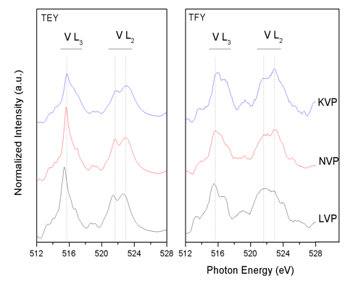
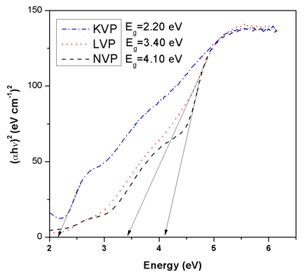
Analysis of the electronic structures for contending battery electrode materials is an essential step towards understanding intrinsic charge-discharge properties that may provide an avenue for further designed improvement in battery performance (Asakura et al., 2016). NA(LI)SICON-type Na₃V₂(PO₄)₃ (NVP), and Li₃V₂(PO₄)₃ (LVP) are promising cathode materials for both sodium and lithium ion battery applications, respectively. Each material possesses a distinct crystal and electronic structure which allows for high stability, energy storage capacity and fast ionic conduction through an interconnected framework of PO₄ tetrahedra and VO₆ octahedra (Rui et al., 2014; Zhang et al., 2019). K₃V₂(PO₄)₃ (KVP) is a recently described analogue to NVP and LVP that reports similar promising electrochemical performance in potassium and sodium ion-based batteries(Han et al., 2017). A significant body of research has been dedicated to the practical optimization of these materials for battery applications, though few studies into their respective electronic structures have been reported.
(b)
(a)
Experimental
In this work, the electronic structures of NVP, LVP and KVP are explored via experimental and DFT computational techniques. For each material, XRD phase-pure, highly crystalline samples were initially prepared and structurally characterised by X-ray diffraction (XRD), scanning electron microscopy (SEM), and energy dispersive X-ray spectroscopy (EDX). To examine and contrast electronic structures, valance states and coordination geometries, X-ray photoemission (XPS) spectra was collected at QUT facilities and near edge x-ray absorption fine structure (NEXAFS) data was collected at the Australian Synchrotron. Optical bandgaps were also investigated experimentally using UV-Vis-NIR diffusion reflectance spectroscopy. Based on these experimental measurements, functionals for DFT calculation of the electronic properties of NVP and LVP are revisited, and for the first time, studied for KVP.
Fig. 1. (a) V-L_{2,3} edge spectra (TEY/TFY), (b) Tauc plots for KVP, LVP, NVP

Results
Figure 1a. displays the V L_{2,3}-edge TEY XAS spectra for NVP, LVP and KVP The main L₃ peak at 515.7 eV and characteristic ‘fingerprint’ patterns in the L₃ pre-peak and L₃₋₂ region confirm the V³⁺ 3d² valence state(Maganas et al., 2014). Good agreement is found in the L₃:L₂ intensity ratio and profile between TEY and TFY spectra for all samples suggesting that the surface electronic structure is free of contamination and fully representative of the bulk. Optical absorption edges obtained for NVP, LVP and KVP, indicate band gaps at 4.10, 3.40, and 2.20 eV, respectively. In general, GGA calculations underestimated band gaps with best agreement in GGA+U at Hubbard U values of 3, 6, and 3 eV respectively. Electronic structures for the synthesized pure-phase NVP, LVP and KVP are elucidated experimentally through XPS, sXAS and UV-vis-NIR. A DFT-computational approach successfully validates the observed experimental band gaps and suggests specific DFT functionals are better suited to further analysis of the electronic properties of NVP, LVP and KVP.

References
1. Asakura, D. et al., (2016). AIP Advances, 6(3). doi:10.1063/1.4943673
2. Han, J. et al., (2017). (Camb), 53(11), 1805-1808. doi:10.1039/c6cc10065a
3. Maganas, D. et al., (2014). Physical Chemistry Chemical Physics, 16(1), 264-276. doi:10.1039/C3CP52711E
4. Rui, X. et al., (2014). Journal of Power Sources, 258, 19-38. doi:https://doi.org/10.1016/j.jpowsour.2014.01.126
5. Zhang, X. et al., (2019). Nanoscale, 11(6), 2556-2576. doi:10.1039/c8nr09391a

