Photocatalytic water splitting for large scale solar hydrogen production

Kazunari Domen^{A,B}

^{A}Research Initiative for Supra-Materials, Shinshu University, Nagano, Japan; ^{B}Office of University Professor, The University of Tokyo, Tokyo, Japan.

Sunlight-driven water splitting has been studied actively for production of renewable solar hydrogen as a storable and transportable energy carrier.¹ Both the efficiency and the scalability of water-splitting systems are essential factors for practical utilization of renewable solar hydrogen. Development of particulate photocatalysts driving overall water splitting efficiently has a significant impact because they can be spread over a large area using inexpensive processes. In my talk, the latest progress in photocatalytic materials and reactors and concepts toward large-scale demonstration will be presented.
The author's group has been developing panel reactors that accommodate photo-catalyst sheets in view of large-scale application. A prototype panel reactor containing Al-doped SrTiO₃ photocatalyst sheets splits water and releases product hydrogen and oxygen gas bubbles at a rate corresponding to a solar-to-hydrogen energy conversion efficiency of 10% under intense UV illumination even when the water depth is merely 1 mm,² and it can maintain the activity over several months under sunlight illumination.³ A 1-m²-sized photocatalyst panel reactor splits water under natural sunlight irradiation without a significant loss of the intrinsic activity of the photocatalyst sheets (Fig. 1). Panel reactors can accommodate various kinds of photocatalyst sheets and are expected to be built using light and inexpensive materials, being suitable for large-scale solar hydrogen production from water. A prototype solar hydrogen production system is currently under construction.
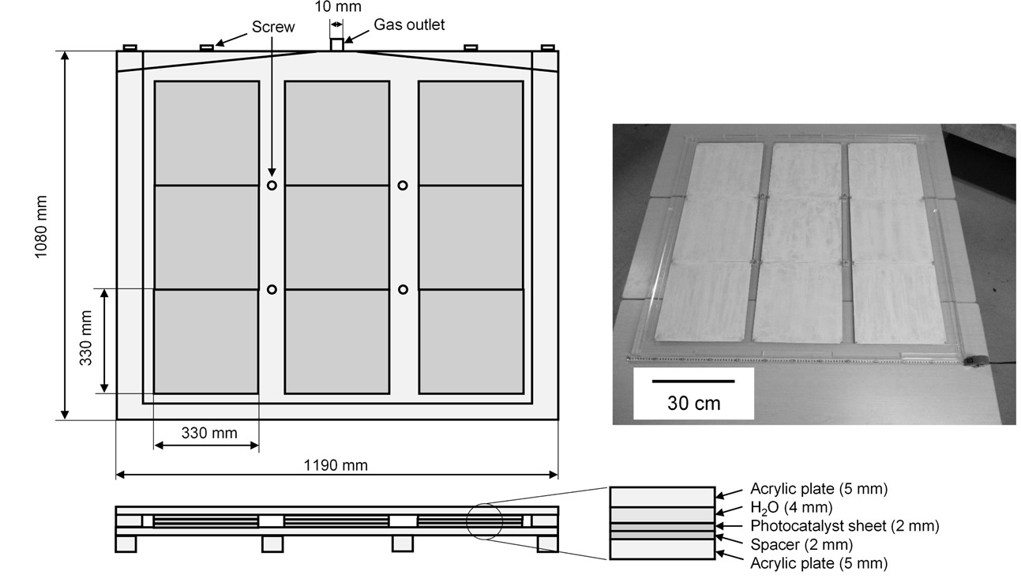
Fig. 1. A 1-m²-sized photocatalyst panel reactor accommodating photocatalyst sheets. Reprinted with permission from ref. 2. Copyright © 2017 Elsevier Inc.

In practice, it is essential to develop photocatalysts active under visible light irradiation. Various oxides, (oxy)nitrides, and (oxy)chalcogenides have been developed.⁴ Some non-oxide photocatalysts can split water into hydrogen and oxygen under irradiation of up to approximately 600 nm. Two different photocatalysts can also be combined so that hydrogen and oxygen are evolved on the respective photocatalysts efficiently.

References
- Hisatomi, T. & Domen, K. (2019). Reaction systems for solar hydrogen production via water splitting with particulate semiconductor photocatalysts. Nat. Catal., 2, 387–399.
- Goto et al., (2018). A Particulate Photocatalyst Water-Splitting Panel for Large-Scale Solar Hydrogen Generation. Joule, 2, 509-520.
- Lyu et al., (2019). An Al-doped SrTiO₃ photocatalyst maintaining sunlight-driven overall water splitting activity for over 1000 h of constant illumination Chem. Sci., 10, 3196-3201.
- Chen et al., (2017). Particulate photocatalysts for overall water splitting. Nat. Rev. Mater., 2, 17050.

