Environmental controls reveal trap exciton dynamics in quantum dots

Gangcheng Yuan^{A,B}, Arun Ashokan^{B}, Paul Mulvaney^{B} , Alison M. Funston^{A}
^{A}ARC Centre of Excellence in Exciton Science & School of Chemistry, Monash University, Clayton, Victoria 3800, Australia;
^{B}ARC Centre of Excellence in Exciton Science & School of Chemistry, University of Melbourne, Parkville, Victoria 3010, Australia

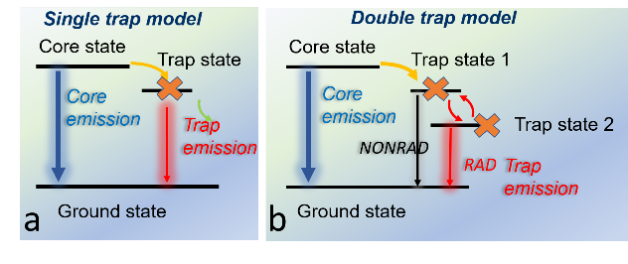
Introduction.
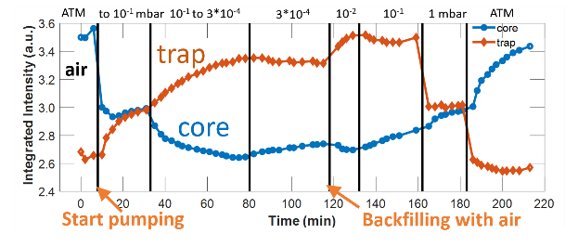
One of major challenges facing nanoscience is the understanding of the complex physics and chemistry at the surface. This is even more critical for quantum dots (QDs) due to their high surface-area-to-volume ratio. For example, a three-nanometre CdSe QD has 50% of its atoms present at the surface. So many surface traps can form among these uncoordinated atoms, affecting significantly the process of carrier generation, transportation and recombination.^{1,2} Surface traps not only quench QD band-edge emission (core emission), but also generate low-energy fluorescence, “trap emission”. But the trap emission mechanism is still poorly understood.
Fig. 1. Trap emission model: (a) traditional trap model; (b) double trap model.
Fig. 2. Core and trap emission vs air pressure.
Vertical black lines indicate the change of pressure.
Aim & Methods.
To understand trap emission, we measured trap emission while controlling gas type and pressure (vacuum). A drop of CdSe/hexane solution was cast on a glass slide, and mounted in a vacuum chamber. Fluorescence from the band-edge and trap state was monitored during the cycle of pumping and refilling with air, nitrogen and oxygen. The varying pressure modulates trap passivation via the gas adsorption and desorption.

Results & Discussion.
When pressure increases in the presence of oxygen, the oxygen passivates the surface traps by adsorption, and therefore core emission increases and trap emission decreases; when oxygen desorbs upon a reduction in pressure, more traps are unpassivated, which quenches core emission and generates more trap emission. This is consistent with the simple trap emission model in Fig. 1. (a). However, core and trap emission do not change at the same rate, inconsistent with the simple model. When pressure increases, trap emission jumps to low level while core emission only increases slowly (Fig. 2.). To explain it, we propose a modified model shown in Fig.1(b). In this model, there are two types of trap, providing nonradiative and radiative pathways, respectively. When pressure increases, oxygen immediately passivates radiative channel, i.e., trap state 2, and thus suppresses trap emission. However, it takes a while to passivate the nonradative channel, trap state 1. Therefore, core exciton can still decay nonradiatively through trap state 1 before complete passivation. To validate the model, we also investigate temperature dependence of trap emission and the role of oxygen and light in trap passivation.

Conclusion.
We study surface trap emission mechanism via oxygen passivation modulation and propose a modified model involving two types of trap.

References
- Giansante, C. & Infante I.(2017). Surface traps in colloidal quantum Dots: a combined experimental and theoretical perspective. J. Phys. Chem. Lett., 8 (20), 5209-5215.
- Yuan, G.; Gómez, D.E.; Kirkwood, N.; Boldt, k.; & Mulvaney P. (2018). Two mechanisms determine quantum dot blinking. ACS Nano, 12 (4), 3397-3405.
Corresponding author: gangcheng.yuan1@monash.edu

