Design and Application of Defects in Electrocatalysis

Yi (Alec) Jia ^{A}* and Xiangdong Yao^{A}*

^{A}School of Environment and Science, Queensland Micro- and Nanotechnology Centre, Griffith University, Nathan campus, QLD 4111, Australia.

E-mail: y.jia@griffith.edu.au, x.yao@griffith.edu.au

Carbon-based metal-free materials have been attracting numerous interests for electrocatalysis due to various merits such as abundance, low cost, high conductivity and tunable molecular structures. However, to date, the electrochemical activities of these electrocatalysts are mainly attributed to different active dopants (e.g., N, B, P or S), leading to a common concept that heteroatom doping is essential for metal-free electrocatalysts. Recently, we presented a new concept that the specific topological defects can activate the oxygen reduction reaction (ORR) and developed a facile method to create such unique defects.^{1,2} Subsequent research extends this new mechanism to other reactions such as hydrogen and oxygen evolution (HER and OER) and confirms that heteroatom doping is not essential but these defects can serve as actives sites for electrochemical reactions.³ This new theory then creates a new research direction of metal-free electrocatalysis. In this talk, the latest studies of defect-induced carbon based materials for advanced electrocatalysts are summarized and presented, especially highlighting on various approaches to prepare defective carbons and a defect catalysis mechanism. Finally, the current existing challenges and future working directions for enhancing the performance of defect-implicated carbon based electrocatalysts are proposed, which may afford the guidance to the proof-of-concept atomic design of highly active electrocatalysts for diverse applications in energy conversion and storage.^{4,5}

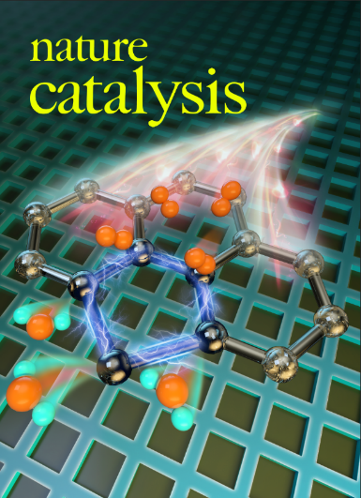

References
- Y. Jia, L. Z. Zhang, L. M. Dai*, X. D. Yao* et al. (2019). Identification of active sites for acidic oxygen reduction on carbon catalysts with and without nitrogen-doping. Nature Catalysis, 2, 688.
- Y. Jia, L. Z. Zhang, A. J. Du, G. P. Gao, J. Chen, X. C. Yan, C. L. Brown, X. D. Yao*. (2016). Defective graphene as a tri-functional catalyst for electrochemical reactions. Adv. Mater., 28, 9532.
- Y. Jia, L. Z. Zhang, G. P. Gao, H. Chen, B. Wang, J. Z. Zhou, M. T. Soo, M. Hong, X. C. Yan, G. R. Qian, J. Zou, A. J. Du and X. D. Yao*, (2017). A heterostructure coupling of Ni-Fe hydroxide nanosheet and defective graphene as a bifunctional electrocatalyst for efficient water splitting. Adv. Mater. 29, 1700017.
- L. Z. Zhang, J. M. T. A. Fischer, Y. Jia*, C. L. Brown, X. D. Yao* et al. (2018). Defect-induced Pt-Co-Se coordinated sites with highly asymmetrical electronic distribution for boosting oxygen-involving electrocatalysis. J. Am. Chem. Soc., 140, 10757.
- Y. Jia, K. Jiang, H. T. Wang*, X. D. Yao* (2019). The Role of Defect Sites in Nanomaterials for Electrocatalytic Energy Conversion. Chem, 5, 1371.

