Protein cages as building blocks for nanomaterials: Binary superlattices and DNA origami encapsulation

Mauri A Kostiainen^{A}
^{A}Department of Bioproducts and Biosystems, Aalto University, Espoo, Finland;

Atomic crystal structure affects the electromagnetic and thermal properties of common matter. Similarly, the nanoscale structure controls the properties of higher length-scale metamaterials, for example nanoparticle superlattices and photonic crystals. We have investigated the self-assembly and characterization of binary solids that consist of crystalline arrays of 1) viruses / other protein cages and 2) other functional units. (Kostiainen et al. 2013) The extremely well-defined structure of protein cages (e.g. CCMV, TMV and ferritins) facilitates the construction of co-crystals with large domain sizes. The use of a second functional unit allows highly selective pre- or post-functionalization with different types of functional units, such as fluorescent dyes (Mikkilä et al. 2016), supramolecular hosts (Beyeh et al. 2018), enzymes (Liljeström et al. 2014) and plasmonic nanoparticles (Liljeström et al. 2017). Our systematic approach identifies the key parameters for the assembly process (ionic strength, electrolyte valence, pH) and highlights the effect of the size and aspect ratio of the virus particles, which ultimately control the crystal structure and lattice constant. Protein-based mesoporous materials, nanoscale multicompartments and metamaterials are all applications that require such high degree of structural control.
We have also shown that native virus particles can be disassembled and the isolated virus capsid proteins can be reassembled on the surface of DNA origami nanostructures. (Mikkilä et al. 2014) Using a “scaffolded artificial genome” (origami) with particular size and 3D shape, offers an interesting way to direct the capsid into nanoshapes that differ from the strictly defined T = n structures, commonly observed with native viruses. Protein encapsulation could also enhance stability and immunocompatibility (Auvinen et al. 2017) of functional DNA origami devices (Ijäs et al. 2019).
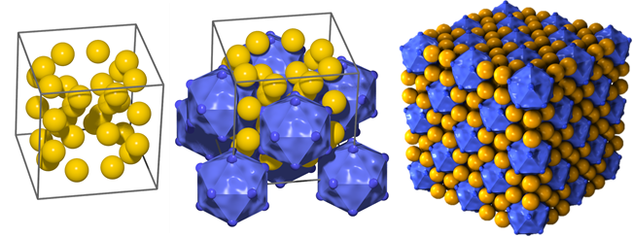
References
1. Auvinen Henni, Hongbo Zhang, Alisa Nonappa, Alisa Kopilow, Elina H. Niemelä, Sami Nummelin, Alexandra Correia, Hélder A. Santos, Veikko Linko, Mauri A. Kostiainen. (2017) Advanced Healthcare Materials 6(18):1700692.
2. Beyeh Ngong Kodiah, Nonappa, Ville Liljeström, Joona Mikkilä, Antti Korpi, Davide Bochicchio, Giovanni M. Pavan, Olli Ikkala, Robin H. A. Ras, Mauri A. Kostiainen. (2018) ACS Nano 12(8):8029–36.
3. Ijäs Heini, Iiris Hakaste, Boxuan Shen, Mauri A. Kostiainen, Veikko Linko. (2019) ACS Nano 13:5959–67.
4. Kostiainen Mauri A., Panu Hiekkataipale, Ari Laiho, Vincent Lemieux, Jani Seitsonen, Janne Ruokolainen, Pierpaolo Ceci. (2013) Nature Nanotech. 8(1):52–56.
5. Liljeström Ville, Joona Mikkilä, and Mauri A. Kostiainen. (2014) Nat. Commun. 5:4445.
6. Liljeström Ville, Ari Ora, Jukka Hassinen, Heikki T. Rekola, Nonappa, Maria Heilala, Ville Hynninen, Jussi J. Joensuu, Robin H. A. Ras, Päivi Törmä, Olli Ikkala, Mauri A. Kostiainen. (2017) Nature Communications 8:671.
7. Mikkilä Joona, E. Anaya-Plaza, V. Liljeström, J. R. Caston, T. Torres, A. De La Escosura, M. A. Kostiainen. (2016) ACS Nano 10(1):1565–71.
8. Mikkilä Joona, Antti-Pekka Eskelinen, Elina H. Niemelä, Veikko Linko, Mikko J. Frilander, Päivi Törmä, Mauri A. Kostiainen. (2014) Nano Lett. 14(4):2196–2200.

