ALD of Transition Metal Di- and Tri-Chalcogenides with Morphology and Phase Control

Ageeth A. Bol^{A}

^{A}Department of Applied Physics, Eindhoven University of Technology, Eindhoven, the Netherlands.

2D materials have been the focus of intense research in the last decade due to their unique physical and chemical properties. This presentation will highlight our recent progress on the synthesis of two-dimensional transition metal di- and tri-chalcogenides (2DTMCs) for nanoelectronics and catalysis applications using atomic layer deposition (ALD). ALD-grown 2DTMC films typically exhibit a high density of out-of-plane 3D structures in addition to 2D horizontal layers. While the out-of-plane 3D structures are ideal for catalysis applications, the presence of such 3D structures can hinder charge transport, which hampers device applications. In this presentation I will show how we used mechanistic insight obtained by HRTEM and DFT simulations to tune the shape and density of the 3D structures during plasma-enhanced ALD. The obtained morphology control was further confirmed by electrocatalysis and electrical measurements.
In the second part of my talk I will demonstrate that we also can modulate the crystal phase of transition metal chalcogenides through ALD. Phase-control between the metallic TiS2 and semiconducting TiS3 phases was achieved by carefully tuning the co-reactant (H2S gas vs plasma) and deposition temperature during ALD. These two material phases were differentiated using a variety of characterization techniques.
This work sets the foundation for achieving electrical and catalytic property modulation through phase and morphology control in low-dimensional materials during ALD.

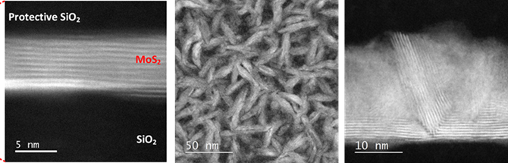

Figure 1: Various morphologies of MoS₂ and WS₂ obtained by tuning the ALD processing parameters. Pictures obtained by HAADF-STEM.

1. Sharma, A., Verheijen, M. A., Wu, L., Karwal, S., Vandalon, V., Knoops, H. C. M., Sundaram, R., Hoffman, J. P., Kessels W. M. M., Bol, A. A., Nanoscale, (2018) 10, 8615.
2. Balasubramanyam, S., Shirazi, M., Bloodgood, M. Wu, L., Verheijen, M. A., Vandalon, V., Kessels, W. M. M., Hofmann, J. P., Bol, A. A., Chem. Mater. (2019) 31, 5104.
3. Basuvalingam, S. B., Zhang, Y., Bloodgood, M., Godiksen, R., Curto, A. Hofmann, J. P., Verheijen, M. A., Kessels, W. M. M., Bol, A. A., Low temperature phase-controlled synthesis of titanium di- and tri-sulfide by atomic layer deposition, Chem. Mater. (2019), DOI: 10.1021/acs.chemmater.9b02895

