Nanowire-based monolithic complementary proton-to-electron transducer using electron beam patterned nafion gates

J.G. Gluschke^{A}, J. Seidl^{A}, R.W. Lyttleton^{A,B}, K. Nguyen^{A}, M. Lagier^{A}, F. Meyer^{A}, P. Krogstrup^{C}, J. Nygård^{C}, S. Lehmann^{B}, A.B. Mostert^{D}, P. Meredith^{D} and A.P. Micolich^{A}
^{A}School of Physics, University of New South Wales, Sydney NSW 2052, Australia; ^{B}NanoLund, Lund University SE-221 00 Lund, Sweden; ^{C}Center for Quantum Devices, University of Copenhagen, Universitetsparken 5, DK-2100 Copenhagen, Denmark; ^{D} Physics Department, Swansea University, Swansea SA2 8PP, Wales, U.K.

Ion-to-electron transduction is at the heart of modern bioelectronics. We recently demonstrated polymer-electrolyte gated nanowire field-effect transistors as a promising materials platform perform for ion-to-electron signal processing [1]. However, our previous polyethylene oxide-based inverter device had three significant shortcomings: the device was not monolithic, it had low gain (<1) and exhibited loss of signal fidelity at frequencies higher than ~10 Hz. Here, we report a new, fully monolithic device based on nafion, a polymer with significantly higher ion mobility, yielding substantially enhanced device performance. Nafion’s high ion mobility has lead to a range of applications ranging from fuel cells [2] to artificial synapses [3]. We developed a process for direct electron-beam patterning of sub-micron nafion channels. These channels were utilized as ionic gates for n-type InAs and p-type GaAs nanowires in inverter devices.
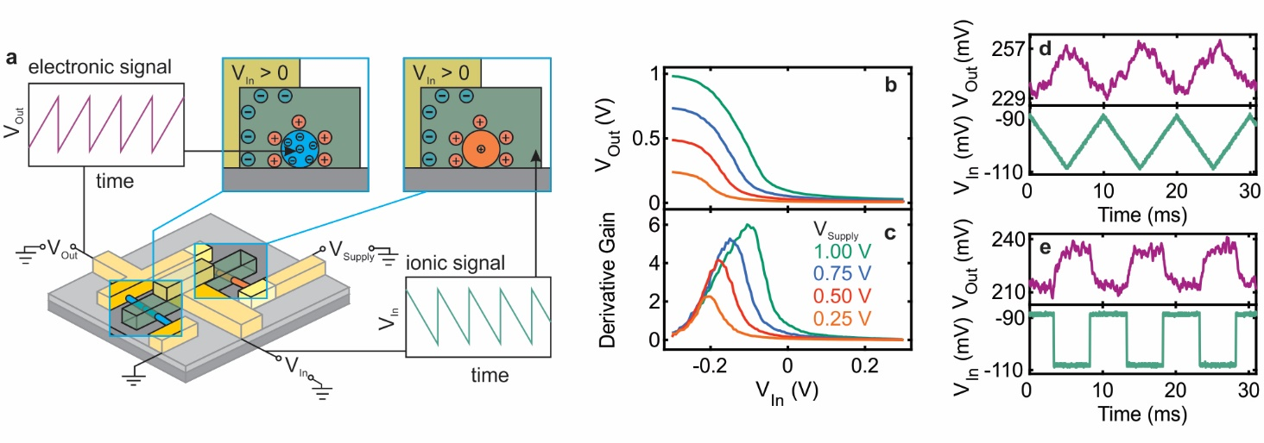Figure 1. (a) Illustration of the nafion (green) gated inverter device with an InAs (blue) and GaAs (red) nanowire. (b) Output voltage V_{Out} vs input voltage V_{in} at four different supply voltages V_{Supply} with (c) corresponding derivative gain. V_{Out} vs V_{In} at V_{Supply} = 1 V signal inversion for a 100 Hz (a) triangular and (b) square waveform.
Figure 1a shows a schematic of a nafion-gated inverter and illustrates the operation principle of the device. A voltage signal is applied to the V_{In} terminal changing the ion distribution in the nafion gates. The change in ion distribution electrostatically modulates the carrier density in the n-type InAs and the p-type GaAs nanowire resulting in a modulation to the output voltage V_{Out} for a constant supply voltage V_{Supply}. Figure 1b shows V_{Out} vs V_{In} for four supply voltages V_{Supply} between 0.25 V and 1 V. Sweeping V_{In} between +0.3 V and −0.3 V is sufficient to modulate V_{Out} between >96% and <2% of the supply voltage. The corresponding derivative amplifier gain is shown in Figure 1c. The maximum derivative gain calculated for this device is 5.9 which is comparable to maximum derivative gain of ∼10 reported for a single InAs/GaSb nanowire CMOS inverter at the same supply voltage [4]. Figure 1d and e show V_{Out} vs time for a 100 Hz triangular and square waveform respectively. Both waveforms were inverted and maintain their characteristic shape. The nafion based ion-to-electron inverters outperform the polyethylene oxide devices [1] by up to two orders of magnitude in gain and one order of magnitude in operating frequency.

References
[1] Carrad, D. J. et al. Nano Lett., 17, 827–833 (2017).
[2] Banerjee, S.; Curtin, D. E. J. Fluor. Chem. 125, 1211–1216 (2004).
[3] Josberger, E. E. et al. Adv. Mater. 26, 4986–4990 (2014). [4] Dey, A. W. et al. Nano Lett. 12, 5593–5597 (2012).

