Solution-processed semiconductor nanostructures for plasmonics and optoelectronics

Enrico Della Gaspera^{A}
^{A}School of Science, RMIT University, Melbourne, Australia

Solution processing is an accessible and versatile approach for synthesizing structurally and chemically controlled nanomaterials. The ability to control the purity, surface chemistry, and microstructure of solution-processed nanomaterials using tailored reaction chemistry and processing conditions will enable to move away from vacuum-based processes. This will reduce the cost and improve the scalability of nanomaterials and related devices, therefore meeting the increasing demand for cheaper consumer electronics.
In this talk, the colloidal synthesis of highly doped plasmonic ZnO nanocrystals will be presented, focussing on doping strategies, scalability, and on the fabrication of nanocrystal-based thin films. Specifically, the incorporation of trivalent (Al, Ga, In) and tetravalent (Ge, Si) cations within ZnO lattice will be discussed (Fig. 1, left panel). The distinctive optical and electrical properties of these doped ZnO colloids will be harnessed through the fabrication of infrared absorbers, transparent electrodes and plasmonic gas sensors. [1-3]
Then the aqueous bath deposition of both intrinsic (semiconductive) and doped (conductive) ZnO thin films will be presented. This method employs only cheap and widely available chemicals, and it produces highly crystalline materials at low temperatures (<80 °C) with excellent control on their morphological, structural and optoelectronic properties (Fig. 1, centre panel). As such, it is amenable for deposition on temperature sensitive substrates such as plastics. Moreover, it is a potentially zero-waste process, a distinctive characteristic that will make this method very appealing for mass production. The high quality of these thin films will be demonstrated by using them to replace vacuum-processed buffer layers and electrodes within high efficiency solar cells and light emitting devices. [4,5]
Finally, the synthesis of highly quantum confined, band gap tunable two-dimensional (2D) SnO nanosheets and indium-doped ZnS quantum dots will be discussed, along with their application as photodetectors targeting specifically UVA and UVB radiation (Fig. 1, right panel). [6,7]

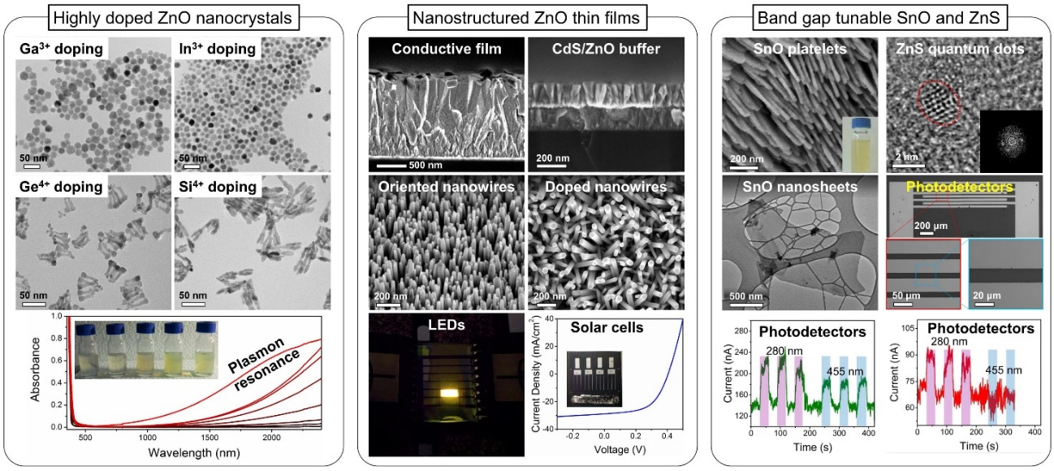
Figure 1. Overview of the results on solution-processed nanostructures presented in this talk.

References
- E. Della Gaspera, et al., J. Am. Chem. Soc., 2013, 139, 3439-3448.
- E. Della Gaspera, et al., ACS Nano, 2014, 8, 9154-9163.
- M. Sturaro, E. Della Gaspera, et al., ACS Appl. Mater. Interfaces, 2016, 8, 30440-30448.
- E. Della Gaspera, et al., ACS Appl. Mater. Interfaces, 2014, 6, 22519-22526.
- E. Della Gaspera, et al., Adv. Funct. Mater., 2015, 25, 7263-7271.
- M. Singh, E. Della Gaspera, et al., 2D Materials, 2017, 2, 025110.
- E. Della Gaspera, et al., Nanoscale, 2019, 11, 3154-3163.

