Investigation of band alignment in plasmonically enhanced hot-electron devices

Shenyou Zhao^{A*}, Jun Peng^{A}, Yiliang Wu^{A}, Fiona J Beck^{A}
^{A}Research School of Electrical, Energy and Materials Engineering, Australian National University,
ACT, Australia.

Introduction
Plasmonic photodetectors have better selectivity than normal semiconductor counterparts in spectral position, polarization, and bandwidth (Brongersma 2016). Plasmonically enhanced hot-electron (PEH) devices, one type of plasmonic photodetectors, are attracting much attention. In a PEH device, hot electrons with sufficient energy will be injected from metal nanoparticles (NPs) into the conduction band of the semiconductor over the Schottky barrier formed at the interface. Experimental demonstrations of solid-state PEH devices that include a hole-transporting material (HTM) layer have so far had very low external quantum efficiency (EQE) at resonance, which is below 6% (Clavero 2014). One main reason is the low efficiency of hot-electron generation, which is mostly determined by the size and shape of the metal NPs. However, the importance of hot-electron collection and transport has not been well studied experimentally. As we know, the metal-semiconductor interface and barrier height (BH) are critical for Schottky junctions (Tung 2014). Therefore, it is likely that the interface and BH between the semiconductor and the metal are important for hot-electron collection and transport in PEH devices.
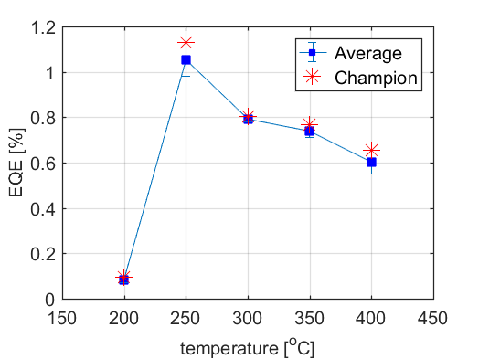
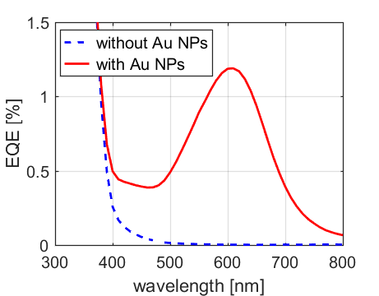
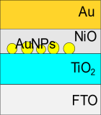
(a)
(b)
Fig. 1. (a) EQE spectra of PEH device shown in inset in (b). (b) Maximum EQE at resonance for different processing temperatures of TiO2. The average EQE (blue squares) are averaged from 4-7 devices, while the red stars are the champion among them.
Aims and methods
In this work, we investigate the impact of barrier height and band alignment between semiconductors and the metal on the performance of PEH devices. The inset of Fig. 1b shows the structure of the device investigated, which consists of n-type TiO2 deposited on fluorine tin oxide (FTO) coated glass, gold NPs, p-type NiO as the HTM, and gold electrode on the top. By varying the temperatures and thicknesses of the semiconductor, we experimentally investigate the role of band alignment and BH in hot-electron injection and transport using a range of characterization techniques to determine photoelectric device performance parameters as well as surface morphology and material properties.

Results and discussion
Fig. 1a shows the EQE spectra for a typical PEH device with and without gold NPs. Fig. 1b shows that the EQE at resonance is affected by the processing temperatures of the TiO2, likely due to differences in the semiconductor morphology. Further work studying the materials will determine which material properties of the semiconductor can affect the hot-electron injection and transport in PEH devices.

Conclusion
The properties of the semiconductor as well as the size and shape of the metal nanostructures is important for the performance of the devices. This leads to another design pathway for the improvement of the performance of PEH devices.

References
Brongersma, M. L. (2016). Proceedings of the IEEE, 104(12), 2349–2361.
Clavero, C. (2014). Nature Photonics, 8(2), 95–103.
Tung, R. T. (2014). Applied Physics Reviews, 1(1).
*Corresponding author: shenyou.zhao@anu.edu.au

