Large Area InP Nanopillars for Solar Energy Conversion

Parvathala Reddy Narangari ^{1, 2}, Siva Krishna Karuturi ^{1,2}, Joshua Butson ¹, Hark Hoe Tan ¹, and Chennupati Jagadish ¹

¹ Electronic Materials Engineering, Research School of Physics, ² Research School of Electrical, Energy and Materials Engineering, Australian National University, Australia, ACT 2601

Photovoltaics and solar water splitting are currently the most promising technologies for converting sunlight into usable forms of energy among existing renewable energy technologies. The basic working principle of the two technologies is the same, with a semiconductor generating electrons and holes upon the incidence of sunlight. The photogenerated carriers contribute to electricity generation in photovoltaics, while they are utilised to split water into hydrogen and oxygen in solar water splitting to produce valuable chemical fuels. Indium phosphide (InP) is a proven semiconductor material to achieve high conversion efficiency for both photovoltaics and solar water splitting applications due to its high absorption coefficient, direct band gap, high crystalline nature, suitable band gap for capturing the maximum portion of sunlight and high resistance to solar radiation [1-2]. In addition, nanostructured InP offers advantages such as enhanced light absorption, reduced carrier transfer length and increased semiconductor/electrolyte interface to further improve the performance of the devices.
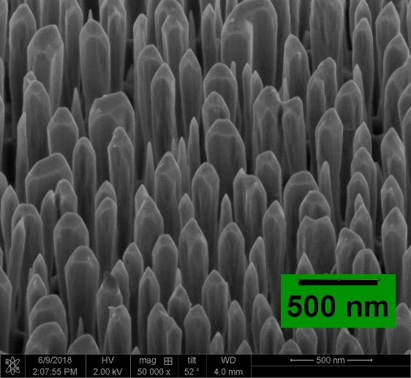
In this work, we present a cost-effective and scalable top-down methodology developed to fabricate large-area InP nanopillars (NPs) and their application as high efficiency photocathodes for photoelectrochemical (PEC) water splitting and solar cells with carrier-selective contacts. InP NPs were fabricated by inductively coupled plasma etching of randomly masked p-type InP (100) wafers, where a Au/SiO₂ random mask was created using a self-assembled random mask technique [3]. NPs were wet treated in sulfur-dissolved oleylamine (S-OA) and HCl to remove the plasma damage caused to the NP surface during plasma etching. InP NPs exhibited highly stable and exceptional PEC performance as a photocathode after S-OA treatment (Fig 1). NPs achieved a saturation current density of around 34 mA/cm², which is close to the theoretical limit for InP, and a photocathode efficiency of over 5%. Diffuse reflectance, time-resolved photoluminescence, X-ray photoelectron spectroscopy, electrochemical impedance measurements and microstructural characterizations were carried out to understand the PEC performance of the InP NP photocathodes. InP NPs were also investigated for large area carrier-selective contact solar cells (0.25 cm²), with the performance of these devices reaching close to their planar counterparts. We will present the fabrication details, results and analysis of these large area InP NP carrier selective contact solar cells.
Fig 1: SEM image of InP NP photocathode
Acknowledgements: We highly acknowledge the Australian National Fabrication Facility-ACT Node and Australian Research Council for providing fabrication facilities and financial support, respectively.
References
[1] Green M A et al. 2019 Solar cell efficiency tables (Version 53) Progress in Photovoltaics: Research and Applications 27 3-12
[2] Gao L, Cui Y et al. 2016 High-Efficiency InP-Based Photocathode for Hydrogen Production by Interface Energetics Design and Photon Management Advanced Functional Materials 26 679-86
[3] Narangari P R et al. 2017 Improved photoelectrochemical performance of GaN nanopillar photoanodes Nanotechnology 28 154001

