Coherent spin control of s-, p-, d- and f-electrons in a silicon quantum dot

R. C. C. Leon^{A}, C. H. Yang^{A}, J. C. C. Hwang^{A}, J. Camirand Lemyre^{B}, T. Tanttu^{A},
W. Huang^{A}, K. W. Chan^{A}, K. Y. Tan^{C}, F. E. Hudson^{A}, K. M. Itoh^{D},
A. Morello^{A}, A. Laucht^{A}, M. Pioro-Ladrière^{B,E}, A. Saraiva^{A}, A. S. Dzurak^{A}
^{A}Centre for Quantum Computation and Communication Technology, School of Electrical Engineering and Telecommunications, The University of New South Wales, Sydney, Australia;
^{B}Institut Quantique et Département de Physique, Université de Sherbrooke, Sherbrooke, Canada;
^{C}QCD Labs, QTF Centre of Excellence, Department of Applied Physics, Aalto University, Aalto, Finland;
^{D}School of Fundamental Science and Technology, Keio University, Hiyoshi, Yokohama, Japan;
^{E}Quantum Information Science Program, Canadian Institute for Advanced Research, Toronto, Canada

Once the periodic properties of elements were unveiled, chemical bonds could be understood in terms of the valence of atoms. Ideally, this rationale would extend to quantum dots, often termed artificial atoms, and quantum computation could be performed by merely controlling the outer-shell electrons of dot-based qubits. Imperfections in the semiconductor material, including at the atomic scale, disrupt this analogy between atoms and quantum dots, so that real devices seldom display such a systematic many-electron arrangement. We demonstrate here an electrostatically defined quantum dot that is robust to disorder, revealing a well defined shell structure [1]. We observe four shells (31 electrons) with multiplicities given by spin and valley degrees of freedom. We explore various fillings consisting of a single valence electron – namely 1, 5, 13 and 25 electrons – as potential qubits [2], and we identify fillings that yield a total spin-1 on the dot. An integrated micromagnet allows us to perform electrically-driven spin resonance (EDSR) [3]. Higher shell states are shown to be more susceptible to the driving field, leading to faster Rabi rotations of the qubit. We investigate the impact of orbital excitations of the p- and d-shell electrons on single qubits as a function of the dot deformation. This allows us to tune the dot excitation spectrum and exploit it for faster qubit control. Furthermore, hotspots arising from this tunable energy level structure provide a pathway towards fast spin initialisation. The observation of spin-1 states may be exploited in the future to study symmetry-protected topological states in antiferromagnetic spin chains and their application to quantum computing.

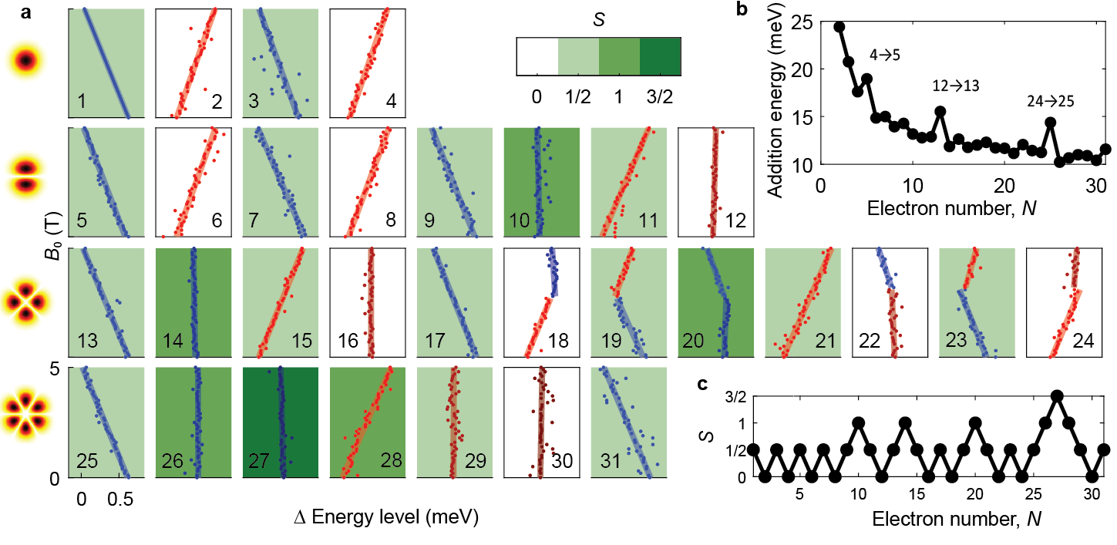

References
- S. Tarucha et al., Physical Review Letters 77, 3613-3616 (1996)
- X. Hu et al., Physical Review A 64, 042312 (2001)
- M. Pioro-Ladriere et al., Nature Physics 4, 776-779 (2008)

