**Presentation Title**

**Presentation format: Choose from -** Case Study / Literature Review/ System Change Review / Personal Story / Alternate Format

**Introduction:**

**Description:**

**Outcomes:**

**Conclusions:**

**References:**

**Table format if included:**

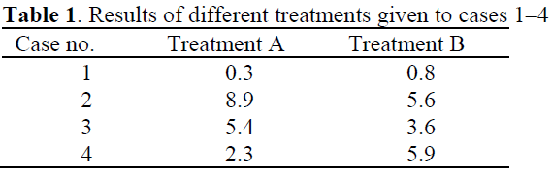

**Reference(s)**

1. Stephens P, Davies KJ, Alkhateeb T, Shepherd JP, Thomas DW: A comparison of the ability of intra oral and extra oral fibroblasts to stimulate extracellular-matrix reorganization in a model of wound contraction. *Journal of Dental Research* 1996; 75: 1358–1364.