Phenotypic differences in wound healing responses are reflected by differences in ECM reorganisation and MMP-2 activation

Background:

Objectives:

Method:

Results:

Conclusion:

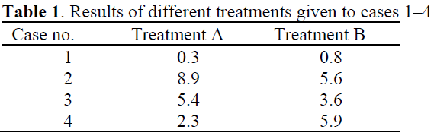

Reference(s)
1. Stephens P, Davies KJ, Alkhateeb T, Shepherd JP, Thomas DW: A comparison of the ability of intra oral and extra oral fibroblasts to stimulate extracellular-matrix reorganization in a model of wound contraction. Journal of Dental Research 1996; 75: 1358–1364.

