TITLE OF PAPER (use heading 1 style)

By

1Author One, 1Author Two, 1Author Three and 2Author Four

¹Organisation, Country
²Organisation, Country

Presenter and Corresponding Author

Presenter Name
Presenter Email

ABSTRACT

Note: Abstracts must be a minimum of 250 words to a maximum of one page. Please include keywords.

Text here (use Text style)

Keywords (use Keywords style):

Note: Insert page break so that Introduction starts on page 2

INTRODUCTION (use heading 1 style)

Text here (use Text style)
Note: Single line spacing with one line between paragraphs

HEADING LEVEL 1 (use heading 1 style)

Heading level 2 (use Heading 2 style)

Text here (use Text style)

- Bullets level 1 (use Bullets 1 style)
  - Bullets level 2 (use Bullets 2 style)

Text here (use Text style)

- Number (use Numbers style)
- Number

Heading level 3 (use Heading 3 style)

Text here (use Text style)

Heading level 4 (use Heading 4 style)

Text here (use Text style)

Note: Figure captions are below figures

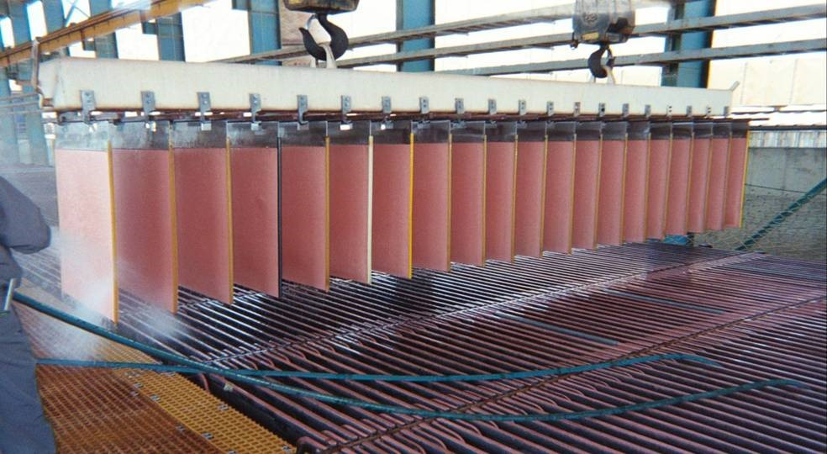

Figure 1: Caption (use Caption style)

Note: Table captions are above tables

Table 1: Caption (use Caption style)

Column 1 Heading | Column 2 Heading | Column 3 Heading
text | text | text
text | text | text

CONCLUSIONS (use Heading 1 style)

Text here (use Text style)

ACKNOWLEDGEMENTS (use Heading 1 style)

Text here (use Text style)

REFERENCES (use Heading 1 style)

- Reference (use References style)
- Reference
- Reference

Formatting check list (refer to Author and Presenter Guidelines for detailed instructions)
- Document in docx or doc format (no pdfs)
- Paper size A4 (297mm long x 210mm wide)
- Page margins Top 1.8cm, Bottom 1cm, Left 2cm, Right 2cm
- Text colour is black throughout
- Text paragraph alignment justified
- All lines single spaced
- Text font Arial 10-pt (except for headings)
- Heading level 1: Arial 11-pt bold all capitals (centred)
- Heading level 2: Arial 11-pt bold title case (left aligned)
- Heading level 3: Arial 10-pt bold title case, italic
- Heading level 4: Arial 10-pt title case, italic
- Figure captions centred below figure in Arial bold 10-pt
- Table titles centred above table in Arial bold 10-pt
- No headers, footers, page numbers, endnotes or footnotes
- No heading numbers or table of contents
- References in text with superscripts after the word e.g. www(1) or xxx(1,2) or yyy(1-3)
- References listed under heading “References” as the final section of the paper
- Spelling, grammar and English language check complete

