Call for Abstract Template – Oral Case Study

This Abstract Template has been provided to assist your submission and to ensure a uniform style throughout the App & Book of Abstracts.
To maintain the formatting of this document please delete this first page and use the 2nd page typing over the text. Please do not type over the headings (Aim, Method, Results, Conclusions).

Please ensure your Abstract is no more than 300 words. Abstract Title is not included in the word count.

Abstracts MUST NOT contain author names, and their organisations, as the Abstract review process will be a blind review.

You should write in full complete sentences, in academic style (not as though you are answering the questions). Please try to avoid writing in the first person.

You should remove the template questions from your final version and include only the headers for each section so that your case study is in the correct format for publishing.

(Please delete the first page prior to uploading & submitting your Abstract).

Abstract Title (font Arial 14pt bold left justified, single spacing, maximum 50 words).

Description
All body text is Arial, 12pt, left-aligned, single spacing before and after each paragraph and single line spacing between each line.

Introduction
All body text is Arial, 12pt, left-aligned, single spacing before and after each paragraph and single line spacing between each line.

Methods
All body text is Arial, 12pt, left-aligned, single spacing before and after each paragraph and single line spacing between each line.

Outcomes
All body text is Arial, 12pt, left-aligned, single spacing before and after each paragraph and single line spacing between each line.

Key Learning Points
All body text is Arial, 12pt, left-aligned, single spacing before and after each paragraph and single line spacing between each line.

References
All body text is Arial, 12pt, left-aligned, single spacing before and after each paragraph and single line spacing between each line.
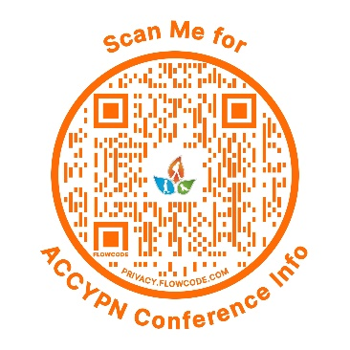
(Delete this first page including logo – prior to uploading & submitting your Abstract).
When completed go to www.accypn.org.au/Conference and follow the links to Abstract to complete the submission process.

Abstract Title (Type over this heading)

Description
Type over this text.

Introduction
Type over this text.

Methods
Type over this text.

Outcomes
Type over this text.

Key Learning Points
Type over this text.

References
Type over this text.

