Call for Abstract Template – Oral & Poster

This Abstract Template has been provided to assist your submission and to ensure a uniform style throughout the App & Book of Abstracts.
To maintain the formatting of this document please delete this first page and use the 2nd page typing over the text. Please do not type over the headings (Aim, Method, Results, Conclusions).

Please ensure your Abstract is no more than 250 words. Abstract Title is not included in the word count.

Abstracts MUST NOT contain author names, and their organisations, as the Abstract review process will be a blind review.

(Please delete the first page prior to uploading & submitting your Abstract).

Abstract Title (font Arial 14pt bold left justified, single spacing, maximum 50 words).

Aim
All body text is Arial, 12pt, left-aligned, single spacing before and after each paragraph and single line spacing between each line.

Method
All body text is Arial, 12pt, left-aligned, single spacing before and after each paragraph and single line spacing between each line.

Results
All body text is Arial, 12pt, left-aligned, single spacing before and after each paragraph and single line spacing between each line.

Conclusions
All body text is Arial, 12pt, left-aligned, single spacing before and after each paragraph and single line spacing between each line.

(Delete this first page including logo – prior to uploading & submitting your Abstract).
When completed go to www.accypn.org.au/Conference and follow the links to Abstract to complete the submission process.

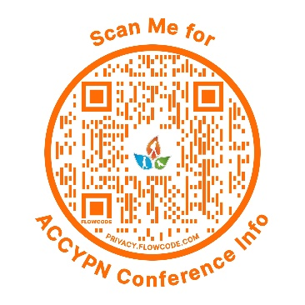

Abstract Title (Type over this heading)

Aim
Type over this text.

Method
Type over this text.

Results
Type over this text.

Conclusions
Type over this text.

