Title of your submission to AIP/AOS/ACOFT/COMMAD 2018

First Name I. LastName1, John A. Smith1,2 and Jane B. Doe2*

1Research School of Physics and Engineering, The Australian National University, Canberra, ACT 0200 Australia

2Affiliation 2, City, Country

* [corresponding.author@email.address](mailto:corresponding.author@email.address)

This is the template for submissions to the joint 23rd Australian Institute of Physics Congress [1], the 2018 Australian Optical Society Conference (AOS2018), 43rd Australian Conference on Optical Fibre Technology (ACOFT) and 2018 Conference on Optoelectronic and Microelectronic Materials and Devices (COMMAD 2018) which will be held at the University of Western Australia, Perth, Australia, from the 9-13 December 2018. Accepted abstracts submitted by registered presenters may be reproduced in printed or online resources of the Congress.

# Differences between AIP/AOS, ACOFT and COMMAD

While AIP/AOS/ACOFT/COMMAD are being run together as a single, unified congress, these subconferences have different submission length requirements and offer different publication opportunities.

Abstracts for AIP and AOS are limited to 1 page. These abstracts will not be published in conference proceedings.

ACOFT papers should be 2-3 pages in length and will be published as ACOFT proceedings.

COMMAD papers need to be 2-4 pages in length. The authors of selected papers of adequate quality submitted to COMMAD 2018 will have the option to have their submission included in peer-reviewed conference proceedings published on the IEEE Xplore platform.

Prior to publication of the ACOFT or COMMAD proceedings, the corresponding authors will be contacted to submit the appropriate copyright forms.

# First step

Copy this template and use it to prepare your submission. Please do not change the page layout or the font format [2].

# Title, author list and affiliations

You simply have to replace the dummy title, authors and affiliations with your own. The presenting author, indicated by an asterix * should be underlined as shown in this template and their email address given below the affiliations. Affiliations should be indicated by numbers.

# Main text

Your main text has a two-column format and uses 10pt Times font. Equations are referenced as shown in Eq. (1):

 (1)

Figures should be captioned. If you have multiple figures we suggest that you present them as subfigures in a single image file and name them Fig.1a, Fig.1b, etc. In this way you save space for your text. Citations should be numbered and appear in brackets like this [2].

# Format of References

Please number citations consecutively in brackets [1]. Sentence punctuation follows the bracket [2]. Refer simply to the reference number, as in [3]—do not use “Ref. [3]” or “reference [3]” except at the beginning of a sentence: “Reference [3] was the first . . .”

For a reference with six or more authors, “et al.” may be used. In other cases, list all authors. Capitalize only the first word in a paper title, except for proper nouns and element symbols. Even if they have been submitted for publication, unpublished papers should be cited as “unpublished” [4]. Papers that have been accepted for publication should be cited as “in press” [5].

# Format and submission steps:

* Use the page layout of this template. Text should be 10pt Times font.
* Generate a pdf file. Make sure that your pdf document **matches the length requires for your conference (AIP/AOS/ACOFT/COMMAD)**.
* Submit the pdf file to the abstract submission portal on [www.aip2018.org.au](http://www.aip2018.org.au) .

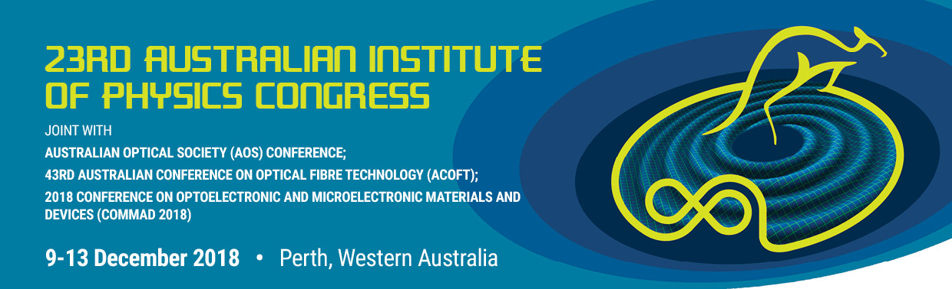

Figure 1: Figure captions are bold 9pt Times font.

# References

1. G. Eason, B. Noble, and I. N. Sneddon, “On certain integrals of Lipschitz-Hankel type involving products of Bessel functions,” Phil. Trans. Roy. Soc. London, vol. A247, pp. 529–551, April 1955. *(references)*
2. J. Clerk Maxwell, A Treatise on Electricity and Magnetism, 3rd ed., vol. 2. Oxford: Clarendon, 1892, pp.68–73.
3. I. S. Jacobs and C. P. Bean, “Fine particles, thin films and exchange anisotropy,” in Magnetism, vol. III, G. T. Rado and H. Suhl, Eds. New York: Academic, 1963, pp. 271–350.
4. K. Elissa, “Title of paper if known,” unpublished.
5. R. Nicole, “Title of paper with only first word capitalized,” J. Name Stand. Abbrev., in press.
6. Y. Yorozu, M. Hirano, K. Oka, and Y. Tagawa, “Electron spectroscopy studies on magneto-optical media and plastic substrate interface,” IEEE Transl. J. Magn. Japan, vol. 2, pp. 740–741, August 1987 [Digests 9th Annual Conf. Magnetics Japan, p. 301, 1982].