##### Paper Title for the 8th International Conference on Advances in Experimental Structural Engineering

**First A. Author1, Second B. Author2, and Third C. Author2**

1 Affiliation of first author, address

e-mail: name@e-mail.address

2 Affiliation of second (and third) author, address

{name2,name3}@e-mail.address

**Abstract**. This document provides information and instructions for preparing a paper to be included in the Proceedings of the 8th International Conference on Advances in Experimental Structural Engineering (8AESE). The paper can be written in Word and be a maximum of 9 pages in length. All the instructions as well as the source for the example files for Word can be found in the website of the Conference.

**Keywords:** Keyword 1, Keyword 2, Keyword 3, Keyword 4, Keyword 5.

## Introduction

Please read carefully the instructions presented herein. This document has been written in the required format and so please study the document for any formatting requirements that are not explicitly stated in the text. Any formatting styles not described herein are left to the authors’ discretion.

## Setting up the Document

The *Page Setup* option under the *File* toolbar in *Word* should be adapted as described in what follows. The margins for A4 size paper should be fixed thus: top 2.0cm, bottom 2.0cm, left and right 2.0cm. The *Header* and *Footer* should be set at 0.7cm and 0.7cm *from edge*, respectively.

## Styles and Formatting

### Fonts and Line Spacing

A decription of the fonts and line spacing used throughout the paper is provided in Table 1. Description of the styles. Styles not included in Table 1. Description of the styles included bullet points which should be placed at 6pt after the paragraph and have the following format:

* 11pt Garamond with exactly 13pt spacing, 0pt before, 3pt after, and 0.63cm tab and 0.63cm hanging should be used in all bullet points,

The last bullet point should have 0pt before, 13pt after spacing.

Table 1. Description of the styles

|  |  |
| --- | --- |
| Style Location | Description |
| Abstract text | 11pt Garamond, 0pt before, 13pt after, exactly 13pt line spacing |
| Acknowledgements text | 11pt Garamond, 0pt before, 13pt after, exactly 13pt line spacing |
| Body Text | 11pt Garamond, 0pt before, 13pt after, exactly 13pt spacing, justified |
| Figure caption | Below figure, 9pt Garamond, bold, 6pt before, 6pt after, single spacing, centred. |
| Table Text | Header: 10pt Garamond, bold, 3pt before, 3pt after, single spacing, Row: 10pt Garamond, 2pt before, 2pt after, single spacing, |
| Table caption | Above table, 9pt Garamond, bold, 6pt before, 6pt after, single spacing, centred |
| References (list) | 10pt Garamond, 0pt before, 13pt after, exactly 13pt spacing, hanging 0.75cm |
| Reference Title | 14pt Garamond, ALL CAPS, bold, 6pt before, 6pt after. |

Numbered lists should be placed at 6pt after the paragraph and be formatted with numerals in the following way:

1. 11pt Garamond with exactly 13pt spacing, 0pt before, 3pt after, and 0.63cm tab and 0.63cm hanging should be used in all numbered lists,
2. The last numbered list should have spacing 0pt before and 13pt after.

Footnotes should be numbered sequentially in superscript lowercase letters[1].

### The Body Text

The language of the main text should be set to English (U.K.). Abbreviations are allowed but should be spelt out in full when first used. Integers of ten and below are to be spelt out. Foreign language phrases should be italicised (e.g., Latin, French).

### Equations, Figures and Tables

Equations should be centred within the text width, whilst equation numbers should be placed in parentheses and set flush with the right margin, as illustrated in Equation (1):

 (1)

Figures should be included in the paper as illustrated in Figure 1; there should be 3pt space before and 6pt space after each figure. A caption should be inserted ideally using the *Insert* – *Reference* – *Caption* option in *Word* using the format described in Table 1. The captions of figures should be centred.

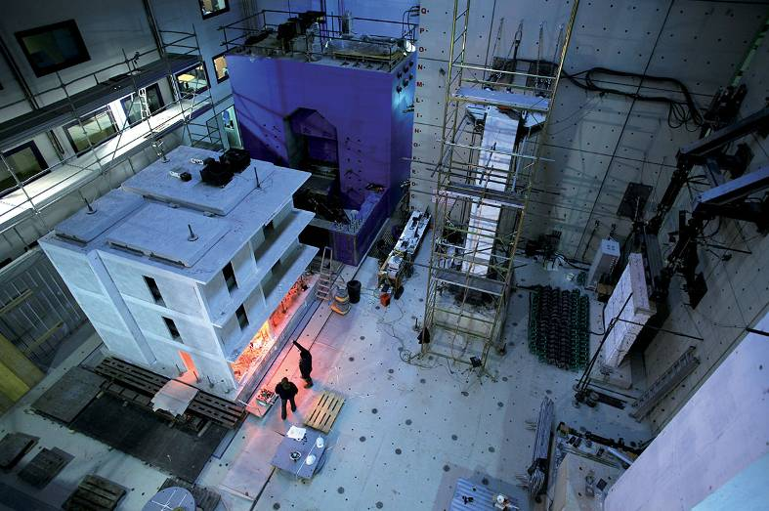

Figure 1. Example of figure and caption

Tables should have either the format shown in Table 2. The captions of tables should be centered.

Table 2. Table captions

|  |  |  |
| --- | --- | --- |
|  |  |  |
|  |  |  |
|  |  |  |
|  |  |  |

### References

All references should be cited in the text by name and year and may take one of the following forms: “…as shown by Miller [1967], the…” or “…has often been demonstrated [Smith and Jones, 2002a, 2002b; Brown *et al*., 2003] that…” The reference list should be placed at the end of the paper, but before any appendices, and must be in alphabetical order by first authors’ surnames and presented in the style shown in the examples in the reference section of these guidelines.

REFERENCES

[Examples of journal references]

Abrahamson, N.A., Bommer, J.J. [2005] “Opinion Paper: Probability and uncertainty in seismic hazard analysis,” *Earthquake Spectra*, Vol. 21, No. 2, pp. 1-5.

Abrahamson, N.A., Silva, W.J. [1997] “Empirical response spectral attenuation relations for shallow crustal earthquakes,” *Seismological Research Letters*; Vol. 68, No. 1, pp. 94-127.

[Example of conference reference]

Abrams, D.P. [1992] “Strength and behaviour of unreinforced masonry elements,” *Proceedings of 10th World Conference on Earthquake Engineering*, Madrid, Spain.

[Example of dissertation / individual study / thesis reference]

Crowley, H. [2005] “An investigative study on the modelling of earthquake hazard for loss assessment,” *Individual Study*, European School for Advanced Studies in Reduction of Seismic Risk (ROSE School), University of Pavia, Italy.

[Example of book reference]

Pinto, P.E., Giannini, R., Franchin, P. [2004] *Methods for Seismic Reliability Analysis of Structures*, IUSS Press, Pavia, Italy.

ICC [2003] *International Building Code*, International Code Council, USA.

1. Footnotes should be typeset in 9pt Garamond at the bottom of the page.