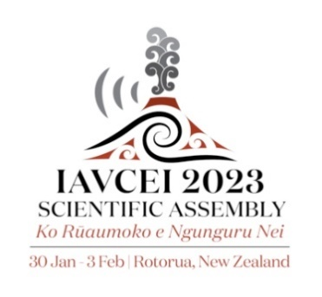
Early-career researcher plenary session application

The Early Career Researcher plenary session is a new addition to the IAVCEI Scientific Assembly 2023. In addition to the typical plenary sessions, a half hour session will also be held each day to showcase excellent early-career researchers and their work. One researcher will showcase their work in each half hour session. The researcher must have a PhD and be within seven years of finishing their PhD, or hold a professional job and have less than seven years of professional volcano-related research experience. This time does not include parental or other relevant leave, with seven years counted up to 2021 to include those that would have been considered an ECR had the conference gone ahead in 2021. We particularly encourage applications from historically under-represented groups. Please note that you do not have to be attending in person to be considered.
Applications for the award are to be submitted in the ECR Plenary Session submission portal on the IAVCEI2023 meeting website. The submission portal will open on the 8th June and close on the 2 September 2022. We ask for:
- Completion of the self-nomination application form which includes a summary of the intended topic, a list of supporting lead-author papers, and a motivation statement on why you should be chosen.
- A short CV (max. 2 pages) including your education and employment history.
The proposed topic should be in addition to an abstract submission and should be broader in scope than a typical conference presentation.

The IAVCEI2023 ECR subgroup of the local organising committee will consider the applications and shortlist candidates for final decision by the wider local organising committee of the meeting.

The review process will take into consideration the following points:
- Significance of your research
- Novelty of your proposed talk
- Application and communication of your research with the wider community
The review panel will also ensure that there is a gender, topic, and nationality balance in the speakers chosen.

For any questions about the ECR plenary session and application process please email Rebecca Fitzgerald at r.fitzgerald@gns.cri.nz

Early-career researcher plenary session application

Your name

Are you post-PhD and are within 7 years (up to 2021 due to COVID) of your completing your PhD not including parental or other relevant leave? Or are a professional who has a maximum of 7 years professional volcano-related research experience? | Yes/No

Email

Title of your proposed presentation:

Briefly describe what you would cover in your plenary presentation (30-minute session)

List supporting lead-author publications or reports

Motivation statement (For example, why do you believe this opportunity would benefit you, the wider volcano community, and/or society in general?)

Any other notable contributions to the research/science community? (Not essential)

Please keep this form to 2 pages max. Please also attach a short CV (max. 2 pages) with this form. Your CV should include your education and employment history.

