Contribution Title

First Author1[0000-1111-2222-3333] and Second Author2[1111-2222-3333-4444] etc.

1 Princeton University, Princeton NJ 08544, USA

2 Institut für Kontinuumsmechanik, Leibniz Universität Hannover  
[author@uni-hannover.de](mailto:author@uni-hannover.de)

Please mark the Corresponding Author with his/her email address

**Abstract.** The abstract should summarize the contents of the paper in short terms, i.e. 150-250 words; justified between the margins and using the font/size specified below.

**Keywords:** First Keyword, Second Keyword, Third Keyword, Forth Keyword, Sixth Keyword.

Page Size, Margins and Font

The page size is standard A4, with the margins listed in Table below. The document is based on the font Times New Roman. The standard font size is 11pt. The paper title is 14pt bold faced. Section titles are 12pt bold faced; subsection titles are 11pt italics. Figure and table captions are 10pt.

|  |  |  |  |
| --- | --- | --- | --- |
| Top | Bottom | Left | Right |
| 2.8 | 2.0 | 2.5 | 2.5 |

Paper Length

Please restrict your paper to a minimum of 6 pages and a maximum of 10 pages, including all figures, tables, and references.

1. First Section
   1. A Subsection Sample

Paragraphs are not indented and should have 12pt spacing between.

Figures/Tables should be centered within the page width and numbered sequentially. Figures/Tables should be numbered separately. Multiple figures should be referred using letters (e.g. Fig. 1a or 1b).

In the text a figure/table is referred as “Fig. 1a shows the drag coefficient...” or “the slope of the lift coefficient switches from negative to positive at the critical Re (Fig. 1b)”.

### Sample Heading (Third Level). Only two levels of headings should be numbered. Lower level headings remain unnumbered; they are formatted as run-in headings.

#### Sample Heading (Forth Level). The contribution should contain no more than four levels of headings. The following Table 1 gives a summary of all heading levels.

**Table 1.** Table captions should be placed above the tables.

|  |  |  |
| --- | --- | --- |
| Heading level | Example | Font size and style |
| Title (centered) | **Lecture Notes** | 14 point, bold |
| 1st-level heading | **1 Introduction** | 12 point, bold |
| 2nd-level heading | **2.1 Printing Area** | 11 point, bold |
| 3rd-level heading | **Run-in Heading in Bold.** Text follows | 11 point, bold |
| 4th-level heading | *Lowest Level Heading.* Text follows | 11 point, italic |

Displayed equations are centered and set on a separate line, and numbered sequentially. Equations must be referred in the text as “Eq. (1) defines strain sensitivity”. Equations must be referred in the text as “Eq. (1)” for one equation or “Eqs. (1), (2) and (3)” for multiple equations.

*x* + *y* = *z* ()

Please try to avoid rasterized images for line-art diagrams and schemas. Whenever possible, use vector graphics instead (see Fig. 1).

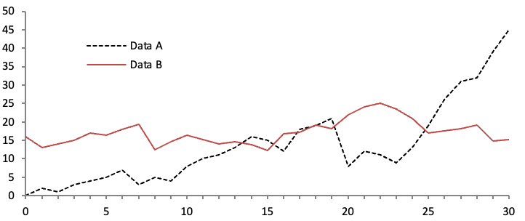

**Fig. 1.** A figure caption is always placed below the illustration. Short captions are centered, while long ones are justified. The macro button chooses the correct format automatically.

For citations of references, we prefer the use of square brackets and consecutive numbers. Citations using labels or the author/year convention are also acceptable. The following bibliography provides a sample reference list with entries for journal articles [1], an LNCS chapter [2], a book [3], proceedings without editors [4], as well as a URL [5].

References

1. Author F (2016) Article title. Journal 2(5):99–110.
2. Author F, Author S (2017) Title of a proceedings paper. In: Editor F, Editor S (eds.) Proceedings Title, pp. 1–13. Springer, Heidelberg.
3. Author F, Author S, Author T (1999) Book title. 2nd edn. Publisher, Location.
4. Author F (2010) Contribution title. In: 9th International Proceedings on Proceedings, pp. 1–2. Publisher, Location.
5. LNCS Homepage, <http://www.springer.com/lncs>, last accessed 2016/11/21.