**Abstract Title**🡪 *‘Title Case’* *12pt bold font Arial, 1.5 line spacing*

A. Damascelli1,2, M. Berciu1,2, D. Bonn1,2 🡪 *12pt font Arial, 1.5 line spacing, underline presenter*

*1 Dept. of Physics & Astronomy, University of British Columbia, Vancouver, BC, Canada*

*2 Quantum Matter Institute, University of British Columbia, Vancouver, BC, Canada*🡪 *12pt Font Arial, italic, 1.0 line spacing*

Your abstract text needs to be submitted in the official conference language, **English**.

Note that the abstract with all information should not exceed **one page** with margins being 2.5 cm top, bottom, left and right. The title should be written in ‘**Title Case**’, i.e., capitalize the first letters of each word except the conjunctions such as *and*, *or*, *at*, *in*, *for*, *the*). Underneath the title, please list the **author(s) name(s) and affiliation(s)**. The next line should be blank. After this line, the abstract text starts with Arial 12pt, justified, 1.0 line spacing. If your abstract includes tables and/or figures, please place them as shown below. Please pay attention that all text is legible and the figure is saved with high resolution. Coloured figures are welcome. Caption text font is Arial 11pt with the caption title (Fig. 1) being bold (see sample below).

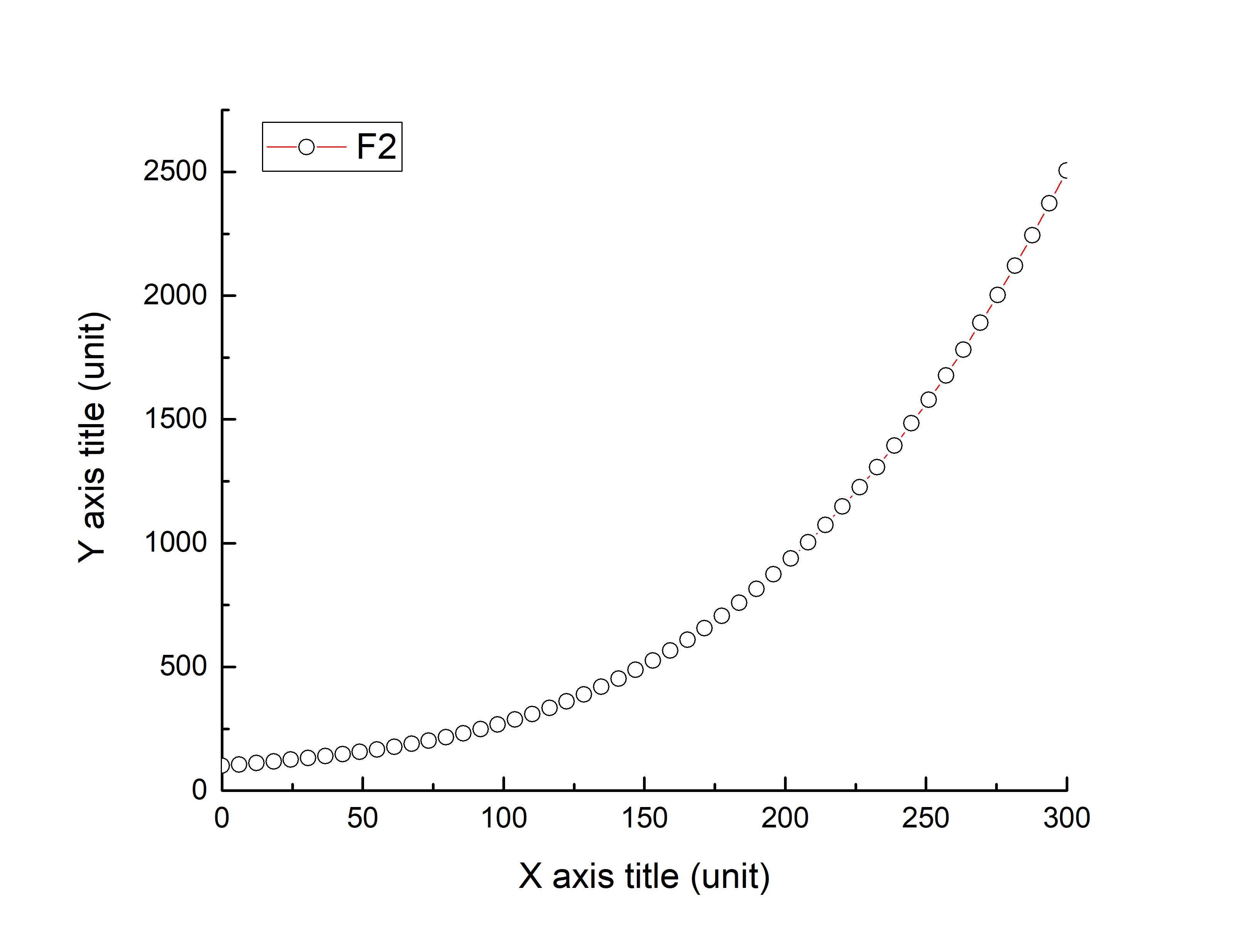

**Fig. 1:** *Caption goes here…* 🡪 *Arial, 11pt, italic*

References can also be given in the abstract (see sample below). Abstract text can flow around the graph/figure.

**References**

[1]. B. J. Author, Phys. Rev. X **20**, 000000 (2021).

[2]. B. J. Author, Phys. Rev. X **21**, 000000 (2021).

***\*The M2S 2022 Conference will not issue proccedings.***